Product  Produmex WMS  Author  Click here to enter text | Document date  3 June 2026  Document version  Version Oct. 2021
confidential
Produmex WMS Business Blueprint
for XXX
Click here to enter subtitle – if no title is used: please remove this field
We reserve all rights in this document and in the information contained therein. Reproduction, use or disclosure to third parties without express authority is strictly forbidden.

Project details
CUSTOMER
Company | COMPANY NAME  Address  Address  Address  T: + XX X XXX XX XX  F: + XX X XXX XX XX  VAT: BE 0XXX.XXX.XXX
Contact | Name  M: + XX X XXX XX XX  Email address
Project | PROJECT NAME

supplier
Company | boyum it solutions bv  Rijvisschestraat 122  9052 Zwijnaarde  Belgium  T: + 32 9 248 16 60
Contact | Name  M: + XX XXX XX XX XX  Email address

distribution list
Name |  | Company |  | Title
Click here to enter text |  | Click here to enter text |  | Click here to enter text
Click here to enter text |  | Click here to enter text |  | Click here to enter text
REVISION HISTORY
Version | Subject |  | Author |  | Date
Text | Click here to enter text |  | Click here to enter text |  | Click for date
Text | Click here to enter text |  | Click here to enter text |  | Click for date
Text | Click here to enter text |  | Click here to enter text |  | Click for date

Table of contents
1. Introduction 9
1.1. The Scope of the Blueprint Document 9
1.2. General Conditions 9
1.3. [CUSTOMER] 9
1.4. Definitions 10
1.4.1. GS1 10
1.5. Devices 11
1.5.1. Fixed Terminals / Touch Screens 11
1.5.2. Mobile Devices 11
1.5.3. Label Printers 12
1.6. Other Terms Used in This Document 12
2. Master Data 13
2.1. WMS Organizational Structure 13
2.1.1. Company 13
2.1.1.1. WMS Company Code 13
2.1.1.2. GS1 Information 13
2.1.1.3. Other Company information 13
2.1.2. Warehouses 14
2.1.3. Docks 15
2.1.4. Production Lines 15
2.1.5. Silo Tanks 16
2.1.6. Zones 16
2.1.7. Moveable Locations 16
2.1.8. Packing Lines 16
2.1.9. Bins 17
2.1.9.1. Bin Code 17
2.1.9.2. Defining Bins 18
2.1.9.3. Bin Sequence 18
2.1.9.4. WMS Bins 19
2.1.9.5. Proposed Bin Code structure 20
2.2. Company-Level Data 20
2.2.1. Quality Status 20
2.2.2. Reasons 21
2.2.3. Print Events 21
2.2.4. Reports 22
2.2.5. Zone Types 22
2.2.6. Logistic Carriers 23
2.3. Item Master Data 24
2.3.1. Main Section 24
2.3.1.1. GTIN 24
2.3.1.2. Non-GTIN item Identifiers 24
2.3.2. General Tab 25
2.3.2.1. Extended Serial / Batch Tracking 25
2.3.3. Produmex / Inventory Tab 26
2.3.4. Produmex / Sales Tab 27
2.3.5. Produmex / Purchasing Tab 28
2.3.6. Produmex / Production Tab 29
2.3.7. Produmex / Catch Weight Tab 30
2.3.8. Produmex / Attributes Tab 31
2.3.8.1. Batch Attributes 32
2.3.8.2. Allergens 32
2.3.9. Produmex / 3PL Tab 32
2.4. Business Partner Master Data 33
2.5. Other WMS Master Data 34
2.5.1. Pick Priorities 34
2.5.2. Picklist Types 34
2.5.3. Shipping Types 35
2.5.4. WMS Users 35
2.5.5. Produmex WMS and External Licenses (SAP, Microsoft) 36
3. Processes 37
3.1. Inbound Logistics Process 37
3.1.1. Goods Receipt 37
3.1.2. Container Management 37
3.1.3. Quality Status 38
3.1.4. Put-Away 38
3.2. Logistics 39
3.2.1. Replenishment 39
3.2.2. Consolidation 39
3.2.3. Moves 39
3.2.3.1. Ad-hoc Moves 39
3.2.3.2. Move Orders 40
3.2.4. Cycle Counting 40
3.3. Stock Allocations 41
3.3.1. Stock Allocations 41
3.3.2. Inventory Locking in Advance 41
3.4. Outbound Logistics Processes 42
3.4.1. Sales Order à Picklist Generation 42
3.4.2. Order Picking 43
3.4.2.1. Picklist Proposal 43
3.4.2.2. Picklist 43
3.4.3. Picking 45
3.4.3.1. Full Pallet Picking 45
3.4.3.2. Item Picking 45
3.4.4. Picking Example 46
3.4.5. Packing 47
3.4.6. Delivery and Shipping 48
3.5. Traceability 48
3.6. Returns 49
3.6.1. Sales Returns 49
3.6.2. Purchase Returns 49
3.7. Production 50
3.7.1. SAP Bills of Material 50
3.7.2. SAP Production Orders 50
3.8. WMS Production Processing 50
3.8.1. Picking Raw Materials 50
3.8.2. Lined Up Raw Materials 50
3.8.3. Weighing Raw Materials 50
3.8.4. Optional WMS Production Steps 51
4. WMS Default Reports 52
5. Data Conversion Strategy 53
5.1. Organizational Structure Data 53
5.2. Organizational Structure Settings 53
5.3. WMS Extended Data 53
5.4. WMS Extensions for SAP Master Data 53
5.5. WMS Data Linked to SAP Master Data 54
5.6. SAP Inventory On-Hand Quantities (Stock Counts) 54
6. Implementation outline 55
7. Change Requests 56
8. Implementation Plan 57
9. test scenarios 58
9.1. Project plan 58
9.2. Testing procedures 58
10. commercial conditions 59
11. approval 60
12. Appendix 1 – GS1 Standards 61
12.1. GTIN and SSCC 61
12.2. GS1 Label 62
12.3. GS1-128 Barcode 62
12.4. SSCC 64
12.5. GTIN 64
13. Appendix 2 – Produmex WMS Process flowcharts 65
13.1. Inbound Logistics 65
13.1.1. Reception Flow 65
13.1.2. Put-away flow 66
13.1.3. Bulk Reception Flow 67
13.1.4. ASN Reception Flow 68
13.1.5. Create Purchase Document Flow 69
13.1.6. Receive from Warehouse Flow 70
13.1.7. Sales Return Flow 71
13.2. Outbound Logistics 72
13.2.1. Purchase Return Flow 72
13.2.2. Picking Flow 73
13.2.3. Multi-picking Flow 74
13.2.4. Zone-picking Flow 75
13.2.5. Ad-hoc Picking Flow 76
13.2.6. Packing Flow 77
13.2.7. Mobile Packing Flow 78
13.2.8. Item Packing Flow 79
13.3.1. Consolidated Packing Flow 80
13.3.2. Box Pick-Pack Flow 81
13.3.3. Prepare Carts Flow 82
13.3.4. Cash Register Packing Flow 83
13.3.5. Unload Movable Locations to Docks Flow 84
13.3.6. Shipping Flow 85
13.3.7. Cross Docking Flow 86
13.4. Internal Logistics 87
13.4.1. Ad-Hoc Movements Flow 87
13.4.2. Move Orders Flow 88
13.4.3. Consolidated Move Flow 89
13.4.4. Replenishment Flow 90
13.4.5. Cycle Count Flow 91
13.4.6. Undo Picking Flow 92
13.5. Production Logistics Flows 93
13.5.1. Picking for Production Flow 93
13.5.2. Picklist for Production Flow 94
13.5.3. Unpicking for Production Flow 95
13.5.4. Move Components to Production Line Flow 96
13.5.5. Component Weighing for Production Flow 97
13.5.6. Production Flow 98
13.5.7. Production Disassembly Flow 99
13.5.8. Receipt from Production Flow 100

Introduction

The Scope of the Blueprint Document
The WMS Blueprint is the base implementation document for the Produmex consultants. It defines how WMS will be configured and installed to meet [CUSTOMER]’s requirements.

It is important that [CUSTOMER]’s key users validate this document.

The scope of this logistics project has been discussed during a blueprint session with [CUSTOMER] and the discussion with [CUSTOMER] defines the current processes and procedures that are in place. Based on this input the blueprint has been written. [CUSTOMER] has to validate that the processes & procedures correspond with the desired future way of working. The final budget and project implementation time of this logistics project will be in direct correlation with the scope (configuration & set-up) requested by [CUSTOMER].

General Conditions
Functions that are standard WMS features are may be described here in summary, but this document is not intended to replace or supplement WMS documentation and training. Other WMS resources include:
- WMS documentation: (the ‘Wiki’): http://wiki.produmex.name/doku.php?id=implementation:wms:main.
- General information: https://www.boyum-solutions.com/solutions/logistics/produmex-wms/?L=
- Helpful articles: https://support.boyum-it.com/hc/en-us/categories/360000880093-Produmex-WMS
- WMS feature request page: https://support.boyum-it.com/hc/en-us/community/topics/360000489098-Produmex-WMS-Feature-Requests

[CUSTOMER]
[CUSTOMER] is a [brief description of business]

[CUSTOMER] is currently [running / implementing] SAP Business One, Version [x.y] running in a [SQL / HANA] database.

Definitions

GS1
GS1 is the global standardization body for the definition of standards for the exchange of information throughout the supply chain. GS1 is an independent, not-for-profit organization, which exists through the memberships of company’s world-wide. GS1 standards and extensive supporting information are available on their website: https://www.gs1.org/.
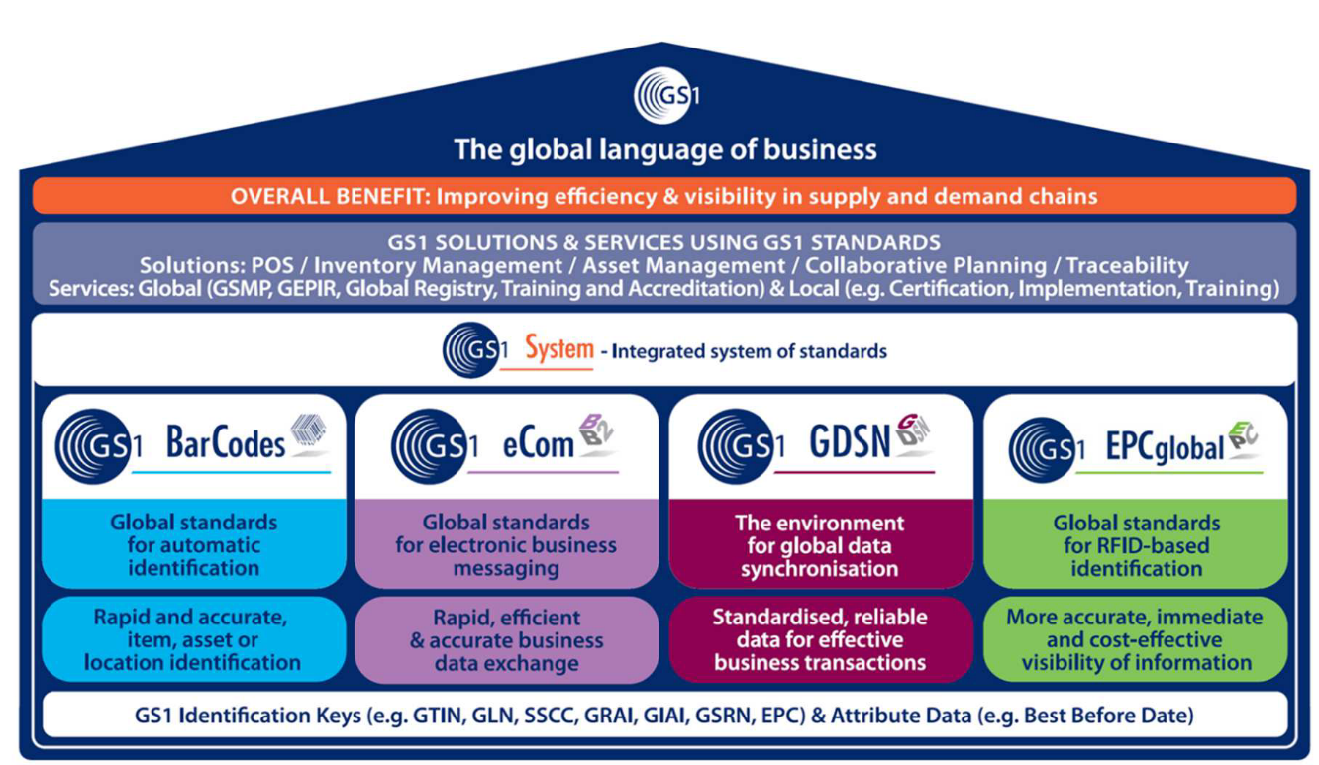

GS1 has established, promotes and supports worldwide standards in the area of
- Barcodes
- Electronic Communication (EDI)
- Global Data Synchronization between supply chain partners
- Electronic Product Codification for RFID based product identification
The Produmex Warehouse Management System for SAP Business One adheres to the GS1 standards.

For further information on the GS1 standards, please consult the appendix or go to: https://www.gs1.org/ or your local GS1 country website.

Devices

Fixed Terminals / Touch Screens
A fixed terminal is a stationary device WMS uses to perform packaging and production operations. This can be either a Touchscreen or a desktop system with keyboard. WMS refers to these devices as ‘Touch Screens’.

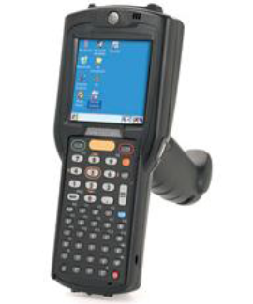
Mobile Devices
The operators in the warehouse are performed using a RF handheld terminal. By scanning barcodes and entering/confirming the required data, the RF Handheld terminal an integral part of WMS and triggers the real-time creation of SAP marketing documents. WMS refers to these devices as ‘Mobile Devices’.

Requirements for mobile devices as of August 2020:
- Wi-Fi network card
- LCD resolution: 240x320 OR 320x320
- LCD size minimum: 3.5 inch
- Barcode scanner
- Windows CE 5+ (preferred), Windows Mobile 6+, Android 4.4.4, Android 6.0

IMPORTANT: Always check the link: http://wiki.produmex.name/doku.php?id=implementation:general:hardwarerequirementsdevice for current mobile device requirements.

Summary of considerations for Mobile Devices:
- Purchase or borrow 1 or 2 testing units upfront with plans to buy the rest after confirming that the unit works well for your requirements
- Will the hardware supplier who sells the mobile devices will take back rejected units for credit?
- Scan range is important, make sure the unit can scan from what are normal distances in the warehouse
- If the device has a physical keyboard then make sure it had dedicated keys for special characters that are likely to be used, such as a dash or period. If it doesn’t have the dedicated key needed, can keys on the physical keyboard can be reprogrammed?
- Make sure the unit is robust enough for the environment. What is the drop rating of the unit? Ratings of a 4-5 feet drop onto concrete are typical.
- Does the model have a wide range of accessories such as holsters, spare batteries, battery chargers?
- Can batteries be changed by warehouse team members without shutting down the mobile device?

This article has more details: https://support.boyum-it.com/hc/en-us/articles/360015106338-How-to-Select-Mobile-Devices-for-Produmex-Scan-or-WMS.

Label Printers
- Driver support for following OS:
  - Microsoft Windows Server 2003 / 2008 / 2012
- Print head size: 4 inch or 6 inch
- Print head density: 200dpi
- Interface: Ethernet and/or Wi-Fi

Other Terms Used in This Document
- Batch Tracking: The ability to track specific quantities of an item that share common characteristics such as manufacture date, production vessel, etc. This term is often used interchangeably with Lot Tracking.
- First Expiry First Out (FEFO): A stock allocation method where stock is selected based on the Batch Expiration Date; stock with the nearest term expiration date is selected first. Only applies to items that are configured to track the expiration date.
- First In First Out (FIFO): A stock allocation method where stock is selected based on the date when the Batch was received into inventory. Stock with the nearest term reception date is selected first. This is an inventory concept which is used separately from the FIFO inventory costing method.
- Sandbox System: A copy of the production or live database used for testing purposes. Also referred to as a Test System.
- Production system: The system where all ERP master data, transaction, etc. occur. Also referred to as the Live System.
- Mobile Device: A device used to perform WMS transactions in the warehouse. Includes both stationary units used for Packing Stations and Production Lines, and mobile units which are carried by warehouse team members. These devices are also referred to as ‘Handhelds’ and ‘Scanners’.
- Robot Tool: A WMS component that can automatically create certain WMS documents such as Picklists

Master Data

WMS Organizational Structure

Company
[CUSTOMER] will manage its various logistics operations (warehouses) underneath one company. The detailed structure of the various warehouses will be defined in the WMS Organizational Structure.

It is possible to import the organizational structure by way of Excel import templates through the standard WMS Import Tool.

WMS Company Code
[CUSTOMER]’s Identifying Code (used within WMS): __________

GS1 Information
[CUSTOMER]’s GS1 Company Prefix is: __________________

[CUSTOMER]’s GS1 starting SSCC number (without Company Prefix) is: __________________

Other Company information
Does [CUSTOMER] provide 3PL services to their customers (Yes / No)? _________

Please provide an image file containing [CUSTOMER]’s logo in a size / format suitable for Mobile Clients (handhelds).
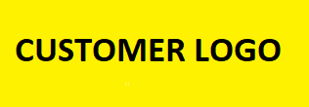

Warehouses
This chart shows the warehouses to be used. The questions help determine deployment and conversion strategies for each warehouse

Code | Name | Exists in SAP? | Uses SAP Bins? | Uses Non-SAP Bins? | Bins From Other WMS, ERP, etc? | WMS Managed? | WMS Transit? | Bin Labels Exist Now? | 3PL - outside provider? | Storage Conditions (Bonded, Freezer, etc.)

See the section below called Data Conversion of On-Hand Inventory for a discussion of how inventory on hand will be imported into WMS.

Docks
Each warehouse must have at least one dock. Docks can be dedicated to either receiving or shipping, or a dock can be dual use.
There should be an SAP workstation at each dock in case receiving or shipping transactions need to be done and the WMS mobile devices are busy. Label printers should be installed near the docks so that labels can be printed near where they will be needed for receiving and shipping.

Dock | Description | Purpose | Inbound, Outbound, Both | Storage Conditions

Production Lines
Production lines only are used when SAP Production Orders are used.

Each Production line has an input bin (for raw materials that are picked for production), an output bin (for finished goods received from production), and an optional Rest Bin (for excess raw materials not used in production).

Description | Input Bin | Output Bin | Rest Bin
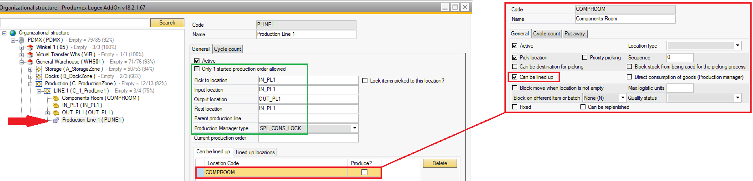

Silo Tanks
WMS Silo Tanks can be used to store raw materials that flow into production.

Zones
Zones and sub-zones help organize the organizational structure. The zones used are often derived from the types of bins that exist (Rack, Floor, etc.), access restrictions withing a warehouse (bonded / non-bonded areas) or the purpose of the area (production, picking, overstock, etc.).

Moveable Locations
Moveable Locations such as carts are used when picking is done for several orders in a Wave. Stock loaded into Moveable Location is then moved to a Packing Station where it is packed for each order.

Description | Warehouse | Zone

Packing Lines
WMS Packing Lines are defined for each physical location where packing occurs in the facility. If there are 8 of these locations, then typically 8 WMS Packing Lines are defined in the OSE.

Description | Printer | Label Printer

Bins
Bins are the basic storage location in the warehouse.

Type | Description | Current Bin Markings | Storage Conditions | Can be Picked for Shipment? | Overflow? | Fixed? | Replenish? | Bin Code Matches Bin Barcode label?

Bin Code
The Bin Code should provide an efficient way to locate the bin within the warehouse. Bin Codes typically have elements indicating the bin’s aisle, location within the aisle, shelf level, etc.

Current Bin Usage
The structure of Bin Codes in the current system have the format:

Defining Bins
This is the WMS Bin entry screen. It includes the Bin Code & Description on the top and other bin attributes with example data.
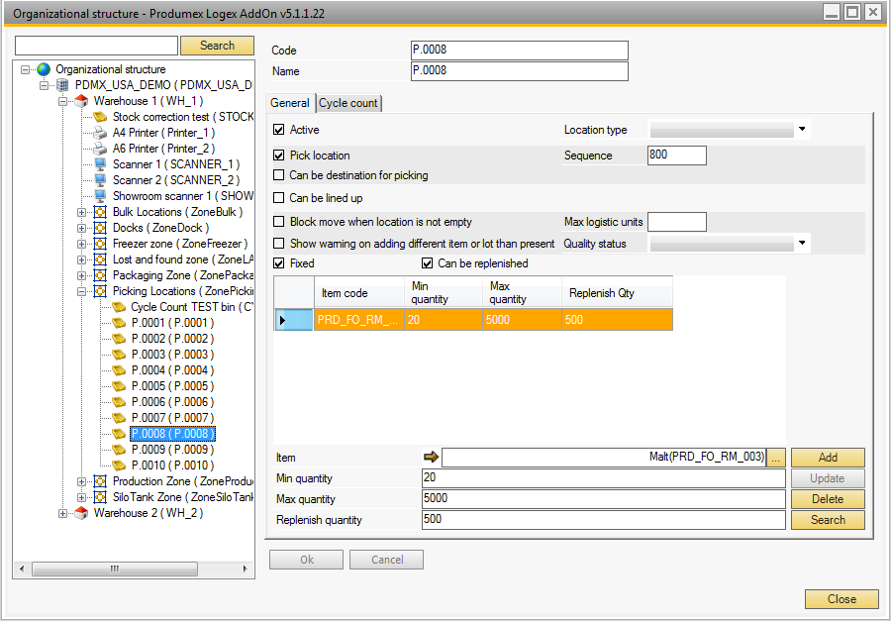

Bin Sequence
Location Sequences will be set up to ensure the shortest walking route in the warehouse during picking.
Every bin location will have a sequence number to ensure the shortest walking route in the warehouse during picking (this can be picking for production, picking for inventory transfer request or sales orders.
See example below:
Location A-01-01 will have the lowest sequence (for ex. 10).
Then location A-01-06 for example will have sequence 60.

A-02-06, sequence 70, and so on via
A-02-05.

C-02-01 will have the highest sequence and is the end point of the walking route in the warehouse.

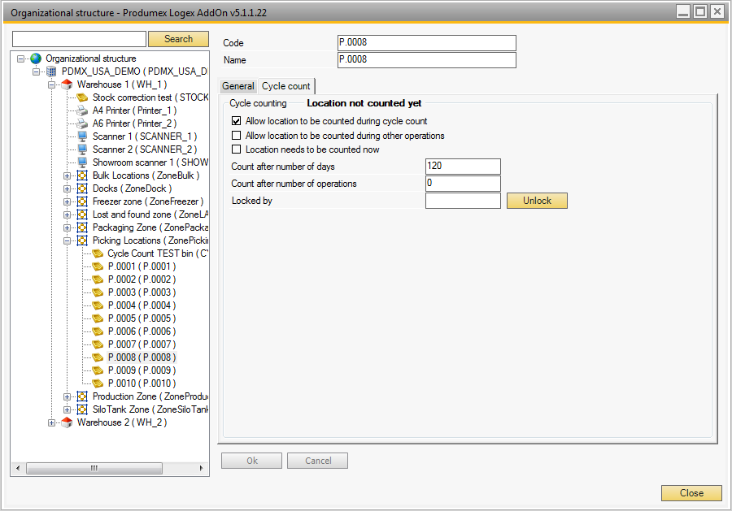

WMS Bins
In addition to the typical rack / floor storage Bins, WMS uses bins to address certain requirements.

Purpose | Warehouse | WMS Bin Code | Notes
Lost and Found |  |  | Used by Cycle Counting
Logistic Carriers |  |  | If using Logistic Carriers
Returned Items

Proposed Bin Code structure
The Bin Code should provide an efficient way to locate the bin within the warehouse. Bin Codes typically have elements indicating the bin’s aisle, location within the aisle, shelf level, etc. The suggested bin code structure for [CUSTOMER] is:

Company-Level Data

Quality Status
Quality Status allows stock in different conditions to be separated and stops stock with certain Quality Status values from used by the system for sales or other transactions. These are examples of typical quality statuses:

Code | Notes | Can Be Shipped? | Can Be Picked - Replen? | Can Be Picked - Prod? | Can Be Used - Prod? | Can Be Put on Pick Loc? | Can Be Shipped Under Quarantine? | Can Be Changed To Quality Statuses
Released | Generally available | Yes | Yes | Yes | Yes | Yes | No | Quarantine; SUG
On Hold |  | No | No | No | No | No | No | Released; Quarantine
Quarantine | Under QC | No | No | No | No | Yes | No | Released; Rejected
Rejected | Failed QC | No | No | No | No | No | No
Returned | Def Status for sales returns | No | No | No | No | No | No | Released; Quarantine; SUG
Blocked |  | No | No | No | No | No | No | Released; Quarantine
SUQ | Shipping Under Quarantine | No | No | No | No | No | Yes | Released; Rejected

Quality statuses codes can be added and changed as needed. The behaviour of the Quality Statuses depends on the setup.

Reasons
User-defined Reason Codes can be used throughout WMS to document issues / concerns that may arise during processing. Reason Codes are defined to be used in specific functions (such as Sales Returns and Quality Status Changes) or they can be shared across different functions.

Examples of Reason Codes include:
- Picking problems: Missing stock - Damaged stock - Damaged packaging -Mislabelled item
- Sales Return reason: Damaged packaging – Mislabelled – etc. …
- Quality Status change: Reasons for returned item refusal: Damaged, Broken, …

Optionally Reasons Codes can be configured to require extra text to be entered by the user.

Code | Name | Extra Text | Picking | Shipping | Sales Ret | Purch Ret | Putaway / Move to Non-Rec’d Bin | Quality Status Change | Purch Receipt | Direct Cycle Count | Zone Type | Containers

Print Events
Print events provide access to print reports and / or labels when certain events occur in the system. The following Print Events can be used:
Code | Event | Notes
100 | Reception: Purchase Delivery Note Created Event | Creation of SAP GRPO document
101 | Reception: New Logistic Unit Identified Event | Scan of new SSCC / pallet during receiving
200 | Picking: New Logistic Unit Full Event
201 | Picking for Production: New Logistic Unit Full Event
202 | Picking: After Wave is Packed | Packing
203 | Picking: Prepare Cart: New Logistic Unit Full Event
204 | Picking: After Item is picked
300 | Shipping: Sales Delivery Note Created Event | Creation of SAP Delivery document
301 | Shipping: Route Shipped Event
302 | Shipping Picklist Shipped Event
303 | PMX Sales Shipping Created Event | See Open Documents Report, Type=PMX Sales Shipping
400 | Production: Logistic Unit Produced Event
401 | Picking for Production: After Picking Event
500 | Packing: Finish Logistic Unit Event
501 | Packing for production: Finish Logistic Unit Event
600 | Sales Order: Sales Order Added Event | Creation of SAP Sales Order document through WMS
700 | Warehouse: A New LU Has Been Created
701 | Warehouse: A Move Has Been Added
702 | Warehouse: A New Master LU Has Been Created
1001 | Customer Specific Print Report Event
2000 | Sales: Reprint Logistic Label

Each report or label will be associated with one of these Print Events.

[CUSTOMER] will use these events in the Reports section as indicated below.

Reports
Report Name | Print Event | Purpose / Use | Type (CR) | Report Definition Name (.rpt) | Orientation (Portrait / Landscape)

Zone Types
Zone Types control which Zones can be used to store certain items. For example, a Zone Type of ‘FREEZER’ might be associated with both the physical freezer location and a zone that includes a freezer at a Dock. Then this Zone Type is associated with all of the items that require this storage condition.

Code | Name | Needs Reason? | Show Zone Type?

Logistic Carriers
Logistic Carriers allow pallets or other storage methods to be tracked in inventory. This is optional. If used each type of logistic carrier must be defined as an Item Master Data record.

Name | Description | Item Master Item Number | Purpose | Amount Customer Pays | Qty Tracked in Inventory?

Item Master Data
The recommendations in this section summarize the approach to be taken. Specific guidance, import / testing strategies, and support will be provided throughout the implementation project.
This discussion does not address optional settings such as remarks and default reason codes. These can be used as needed in the future.

Main Section

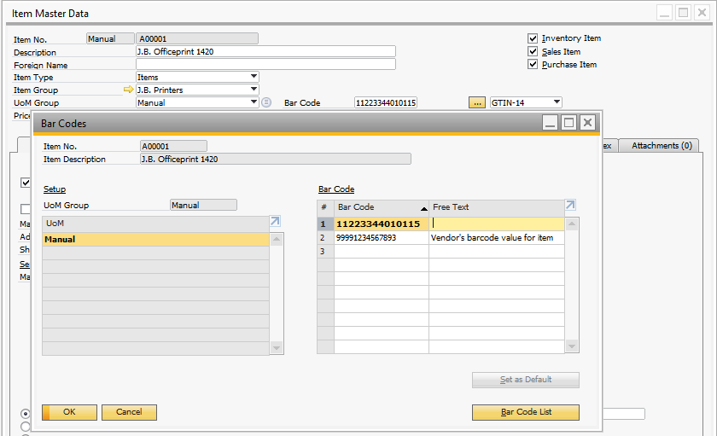
GTIN
The Item’s GTIN value is stored in the SAP Bar Codes table accessed from the button on the top section of the Item Master Data screen. This enables scanning of the GTIN as a stand-alone barcode or as a component of a GS1 barcode.

Non-GTIN item Identifiers
Non-GTIN item identifiers can be stored in the Bar Codes grid by changing the WMS Bar Code Type from GTIN-14 to Free.

General Tab

Extended Serial / Batch Tracking
- WMS includes an option to provide Serial tracking for SAP Batch Tracked Items.
- Use the Track Location of Serial Number setting to enable WMS to track Bin locations for Serialized items (either SAP Serial Numbers or WMS Serial Numbers).
- Use the Serial Number Format to define the serial number structure when WMS’s option to automatically create serial numbers is activated. This applies when goods are received or produced and works with either SAP Serial Numbers or WMS Serial Numbers.

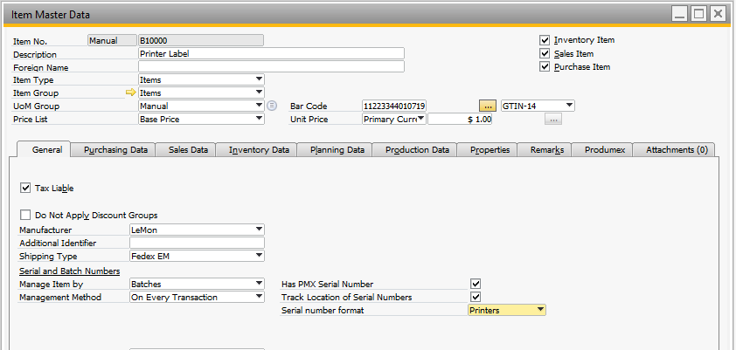

Produmex / Inventory Tab
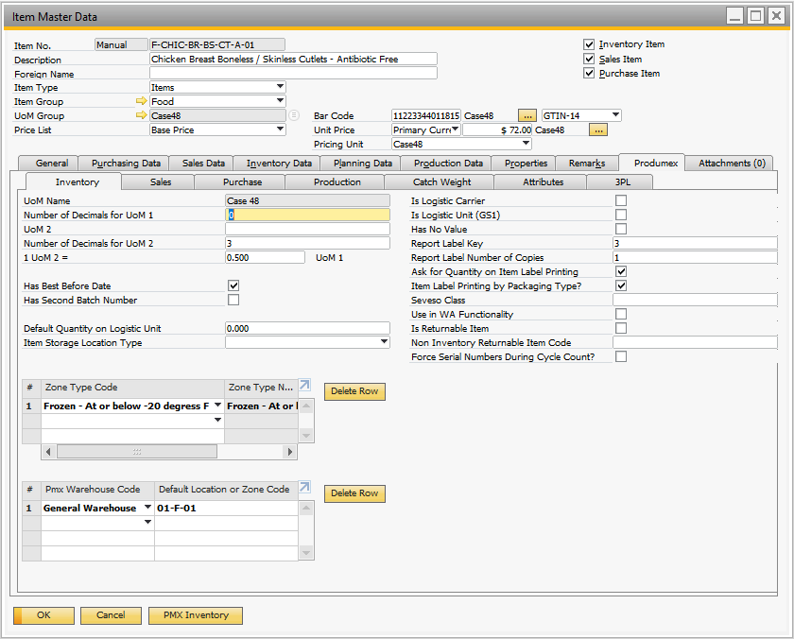

Produmex / Sales Tab
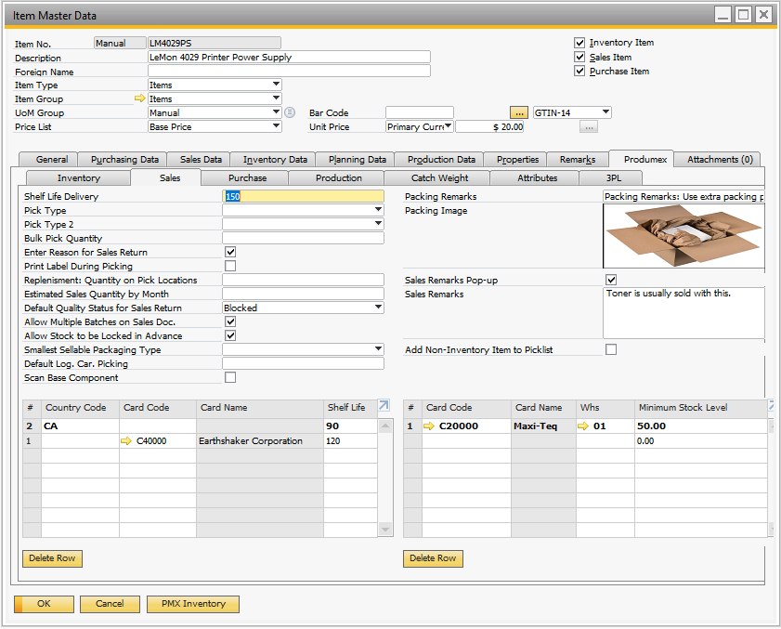

Produmex / Purchasing Tab
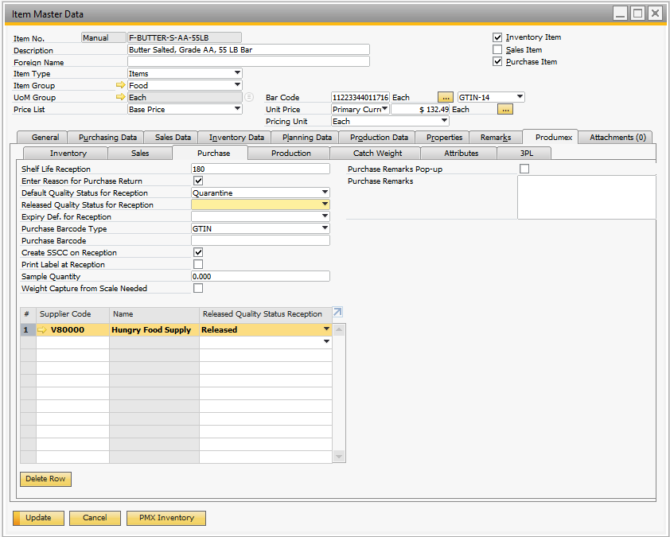

Produmex / Production Tab
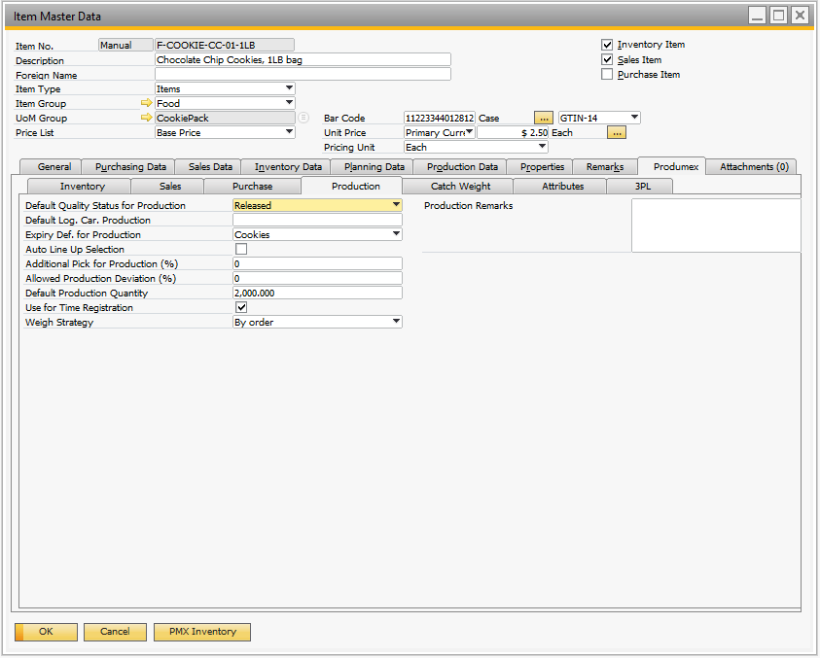

Produmex / Catch Weight Tab
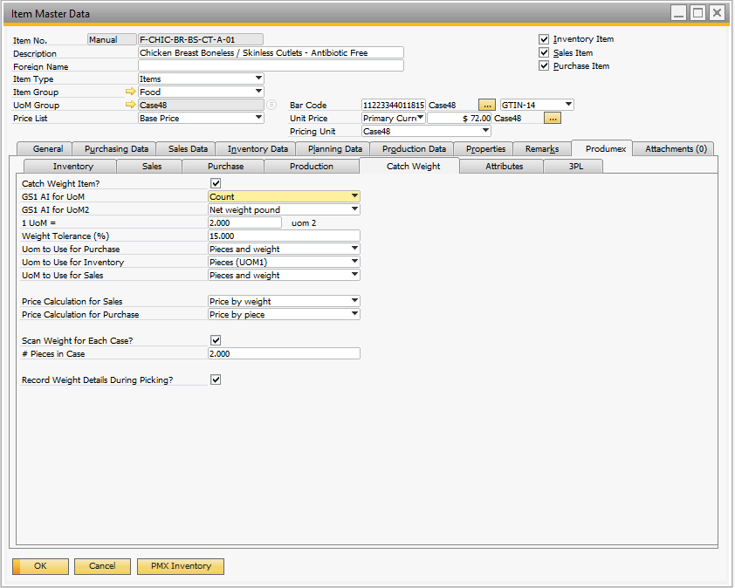

Produmex / Attributes Tab
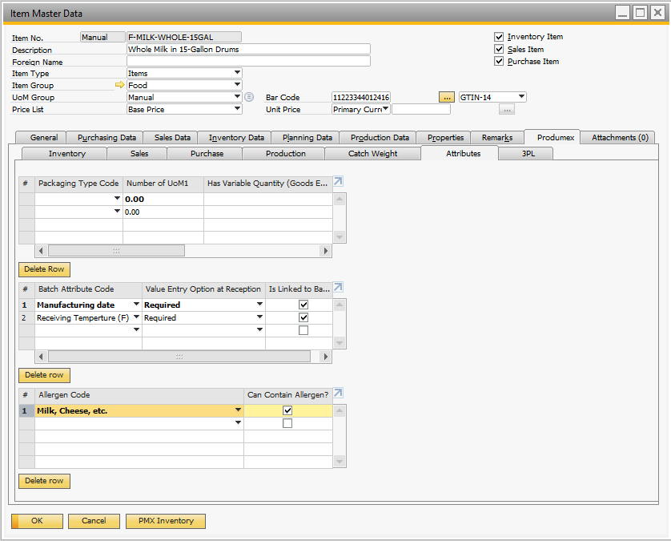

Batch Attributes
Batch Attributes allow additional information to be collected for Batch-Tracked items. Batch Attributes are defined globally, then applied to the items where they are needed. For example, Items A, B, and C are Batch Tracked; the manufacturing date must be collected during receipt for Items B and C; and the temperature recorded for Items B and C.

Allergens
Allergens are user defined and can be applied to items as appropriate. To use Allergens first create the Allergen data:

Allergen Code | Allergen Name

Produmex / 3PL Tab
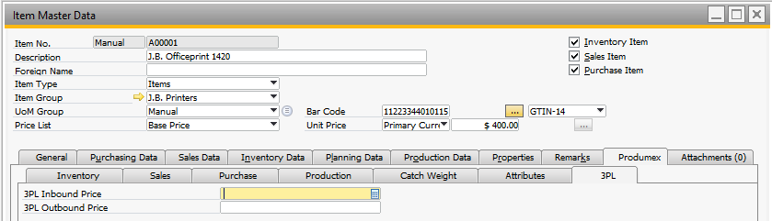

[CUSTOMER] will not setup data on the Produmex / 3PL tab because this functionality doesn’t apply to their operations.

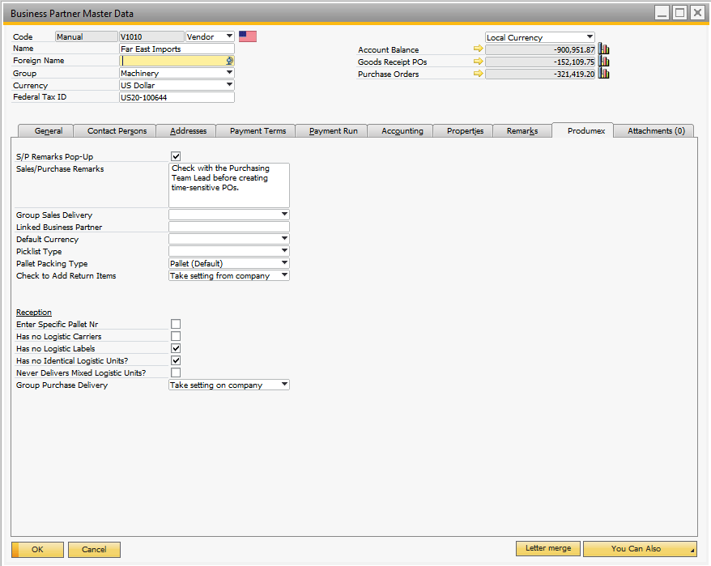
Business Partner Master Data

Suppliers
The Reception controls on the Business Partner should be set to reflect the labels each supplier uses.

Customers
The Picklist Type can be specified by customer. This allows control of the picking / packing / labeling / shipping workflow by customer if needed. See the Picklist Types section below.

Other WMS Master Data

Pick Priorities
On the Picklists it is possible to setup priorities and the system will push these Picklists to the top or bottom of the queue.

Picklist Types
Picklist types define certain aspects of the picking and shipping processes. Any number of Picklist types can be created and then used for the appropriate customer / item combinations. Example Picklist types could include ‘Will Call’, where the customer picks up goods using their own trucks and ‘Our Trucks’ where the AR Invoice must be created when goods are loaded onto the truck. Picklist Types control the following attributes:

Process options:
- Wave or Order Pick?
- Pick for Production (raw materials)?
- Use for Picking (customer shipments)?
- Use Ad hoc Picking?
- Use Zone Picking?
- Use Multi Picking?
- Create Invoice Before Picking?
- Auto Create Picklist For New SO?
- Partial Shipments Allowed?
- Use for Cash Register Packing?
- Consolidate Packing for Multiple Orders to Same Ship-To Address?
- Split Picklist based on Items on Pallet?
- Max Pallets on Picklist
- Split Picklist by Item?

Before Picklist is Created:
- Reserve Stock Inbound on PO?
- Reserve Existing Stock by Batch / Serial?

Print options:
- Pick Ticket Printout?
- Labels Before Packing?
- Labels After Packing?
- Pack Slip After Packing?
- Print after item picked

Data capture options:
- Ask Master SSCC Weight?
- Ask Master SSCC Length?
- Ask Master SSCC Width?
- Ask Master SSCC Height?
- Ask Sub SSCC Weight?
- Ask Sub SSCC Height?
- Ask Sub SSCC Width?
- Ask Sub SSCC Length?

Shipping Types
WMS enables SAP Shipping Types to control the WMS processes such as automatic invoice creation and collection of additional information. It may be necessary to create new Shipping Type data to utilize this functionality.
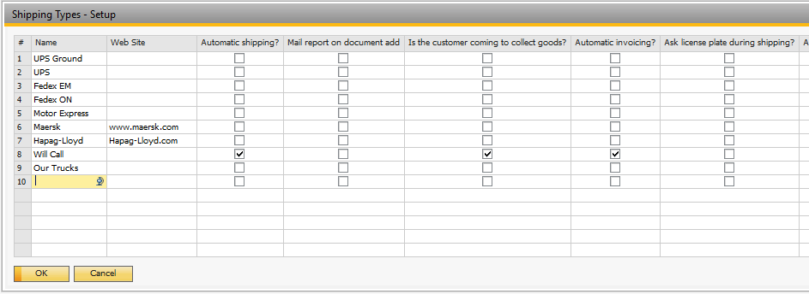

Type | Description | Exists in SAP now? | Customer Pick Up? | Auto Shipping? | Auto Invoicing? | Additional Info (SSCC, driver, trailer #, etc.)

WMS Users
Considerations
- WMS users may or may not be existing SAP users. If WMS Users are not already SAP users, then they will need to be created in SAP and will need to have a minimum of an SAP Indirect User License.
- Some WMS may need to access WMS both from Mobile Devices and from within SAP
User ID | Full Name | Exists in SAP? | Access WMS in office? | Uses Mobile Client? | Role / Responsibilities | Restrictions

Produmex WMS and External Licenses (SAP, Microsoft)
There are various types of Produmex WMS licenses:
- Produmex WMS professional licenses to use the administrative Produmex WMS module within the SAP Business One application. The Produmex WMS professional licenses enable access to WMS functions within SAP Business One, such as creating OSE objects like bins, zones, docks, packing lines, creating picklists, creating move orders, detailed inventory reporting, processing cycle counts, etc.
- Produmex WMS Terminal (or Device) licenses for RF devices (scanners) or packing or production thin clients. The Produmex WMS Terminal license enables use of handheld devices to do operations such as reception, moves, shipping and more. A Produmex WMS RF Terminal user is a device user (1 license per RF terminal device). Take into account that for each Produmex WMS Terminal User also an SAP Business One Indirect Access User License is required, because the RF Terminal users need to have access to the SAP Business One database. As the Produmex WMS Terminal Users connect via a Remote Desktop Connection to a Windows Server, a Microsoft Client Access License (CAL) also needs to be provided for each Produmex WMS Terminal.
- Produmex WMS Module licenses. These include:
  - Produmex WMS 3PL site license – for 3PL invoicing
  - Produmex WMS Automation device license – for integration with automated warehouses (mini-load, AS/RS system, …)
  - Produmex WMS EDI interface site license for Electronic Data Interchange
  - Produmex WMS Connect scale interface device license per controller
  - Produmex WMS Weigh module license for managing weigh orders
[CUSTOMER] plans to use the following licenses:
- Produmex WMS Professional Licenses: [x]
- Produmex WMS Terminal Licenses: [x]
- Produmex WMS 3PL License: [x]
- Produmex WMS Automation License: [x]
- Produmex WMS EDI License: [x]
- Produmex WMS Connect License: [x]
- Produmex WMS Weigh License: [x]
- SAP Indirect Access User Licenses: [x]
- Microsoft Client Access Licenses (CAL): [x]

Additional information on WMS license is on the Wiki, and in this article: https://support.boyum-it.com/hc/en-us/articles/360009856517-WMS-Licensing

Processes

Inbound Logistics Process

Goods Receipt
The receipt of purchased goods will be performed on the Mobile Device against existing SAP Purchase Orders.
- Receiving by pallet (scan the barcode from the supplier)

Below is an example of a receiving flow on the Mobile Device. Note that this is an example only and the steps may vary based upon item, BP master setup.

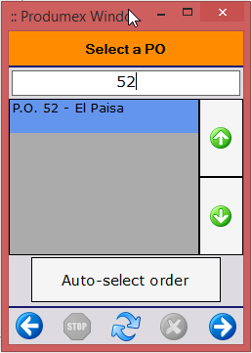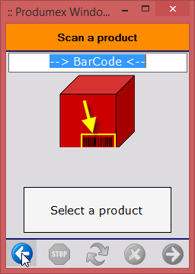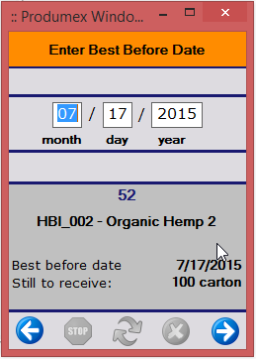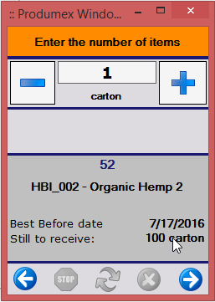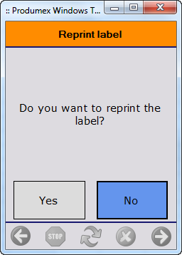

After the receiving process the items are located on the selected receiving dock:
All product received will be received on an SSCC (license plate for the pallet).
During the receiving process the following label will be printed:
- Goods Receipt label will print a SSCC barcode for the pallets;
This SSCC label is a crystal report that will contain all required information for [CUSTOMER] (details need to be discussed)

[CUSTOMER] should test use of the ‘Identical Logistic Units’ option. This streamlines the receiving process.

Container Management
[CUSTOMER] will not use the container management functionality to create a container that will contain multiple PO’s for the accessory items.

Quality Status
Incoming product will be inspected (if necessary – depending on the item).
Product that pass the quality inspections can be put away to the bin locations. Products that fail the inspections will get a quality status of ‘Rejected’ and removed out of inventory.

When products are REJECTED after quality check, we can give a reason and possibly extra information about the rejection. We can later report on this data (and possibly issue out the rejected goods).

The default Quality Status setting for received goods should be Released (or a similar Quality Status code if used). When an issue is found the Quality Status for the unit will be updated to Rejected, Quarantined, etc. either on the mobile device’s Change Quality Status function, or via the WMS Inventory Report’s Change Quality option:
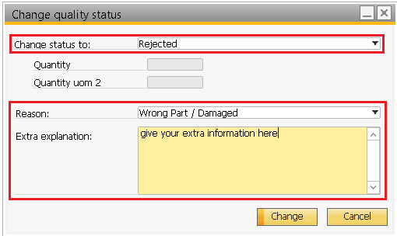
When products are REJECTED after quality check, we can give a reason and possibly extra information about the rejection. Reports can provide analytics based on the Reasons and Quality Status codes. The more granular these codes, the more specific the analytics will be.

Put-Away
After receiving automatically put away orders are created in the system. The put away orders are executed by scanning the SSCC barcode (generated upon receipt) and scanning the destination location.
An example is shown below:

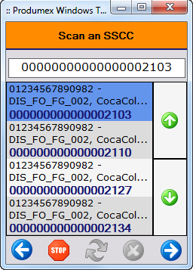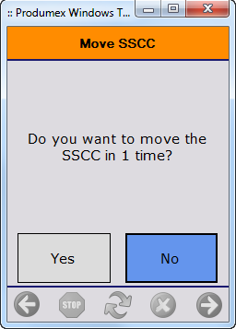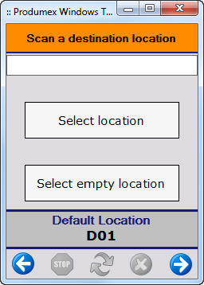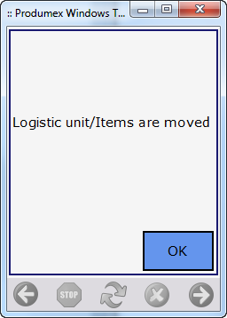

Logistics

Replenishment
WMS Replenishment enables stock levels in pickable bins to be replenished from bulk or overstock locations. Creation of WMS replenishment orders can be scheduled with Windows Task Scheduler or it can be triggered manually.

When replenishment orders are created, they are visible on Mobile Devices and in the Open Documents Report.
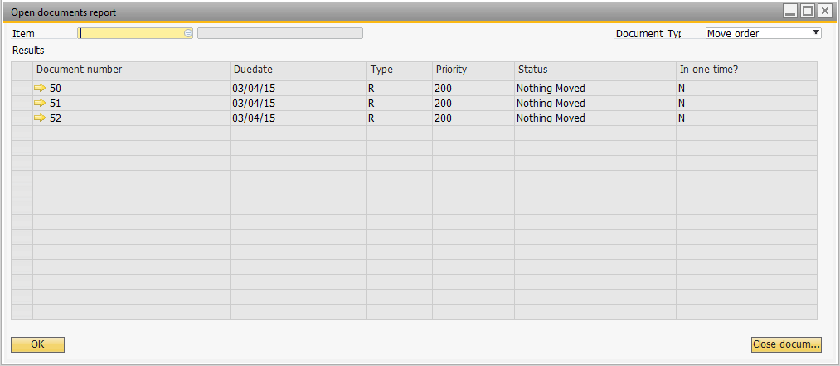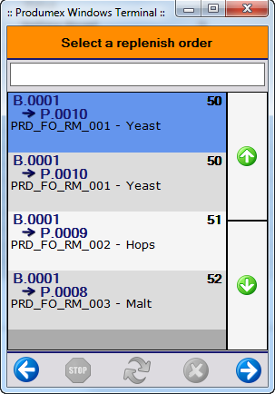

Replenishment requires extra setup on bin level. These settings can be applied manually or can be imported.

[CUSTOMER] is interested in using the replenishment functionality to replenish the pick locations for packaging production step.

Consolidation
[CUSTOMER] expressed interest in using WMS Move Orders to consolidate inventory. While there is no Consolidation menu option, this can be accomplished by automating the creation of Move Orders via the WMS ‘EDI module’ (this is a separate license). Ad-hoc Moves can also be used for consolidation when a warehouse team member sees stock that should be moved / consolidated.

Moves

Ad-hoc Moves
[CUSTOMER] will use ad-hoc moves to do a couple of actions:
- Consolidate open pallets onto 1 pallet to free bin locations
- Move pallets from a source bin into a destination bin

Move Orders
Move Orders allow team members working within SAP to request that a mobile device user move an item from one bin to another.

Cycle Counting
[CUSTOMER] will use only regular cycle counting.
The WMS Cycle Counting options allow counts to be done on the mobile devices for any range of bins, items, item groups, etc. or creation of count tasks can be automated if needed. There are two counting options: Cycle Counts and Direct Cycle Counts. When the Cycle Count option is used then counts are then approved in SAP by and administrative person. This is an example of the WMS Cycle Count Processing screen:
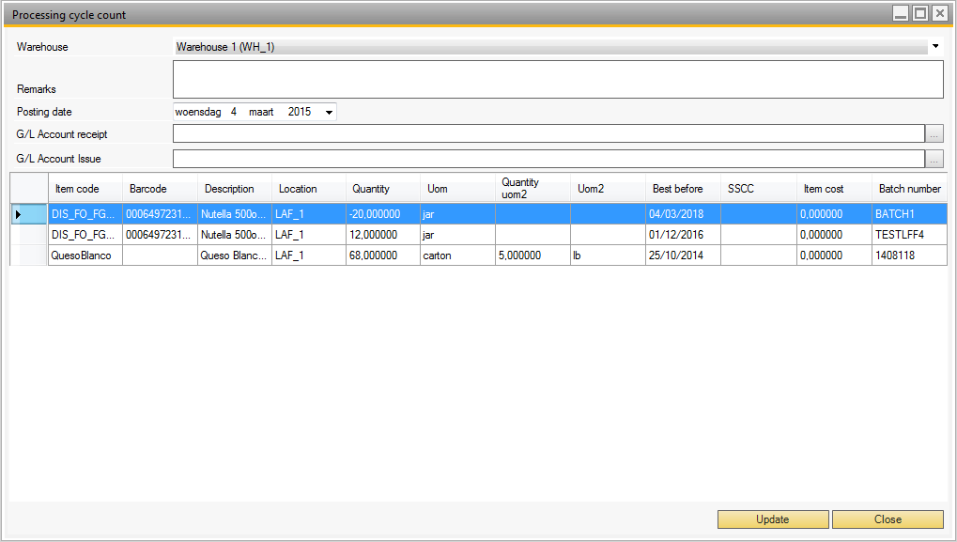

When the Direct method is used then counts immediate impact WMS and SAP on-hand quantities.
The 2-step Cycle Count option is recommended for [CUSTOMER] since they are new to counting on mobile devices. Over time they may choose to start using the Direct option.
With the automated Cycle Count creation process the WMS Robot Tool will check if a location has defined that it must be counted every X days. If the number of days specified are due, the Robot will create a cycle count task in the mobile device.

Stock Allocations

Stock Allocations
WMS uses allocations to restrict access to quantities of inventory, ensuring stock needed for a WMS transaction is not used in a different WMS transaction. Most locking occurs automatically and is released when the transaction completes or when it is manually Closed with having impacted inventory.

[CUSTOMER] would need the ability to lock inventory against a specific sales order/Customer without creating proposals (reserve safety stock). This way other sales orders cannot take that inventory. This is possible by using the allocations mechanisms available in Produmex.
Once the warehouse manager decides to create a Picklist Proposal and Picklist for that order, the locked stock will be used to fulfil the Picklist and proposal.

Inventory Locking in Advance
The ‘Inventory Locking in Advance’ functionality ensures that when the items that are locked arrives in the warehouse these units are automatically allocated to the indicated customers.
To use this functionality, a setting on the item master must be enabled (see master data section) and a Sales Order for the indicated customer must exist in SAP.

Example below: the first 50 Pieces will be reserved for ‘Customer food 1’, the next 250 will be reserved for ‘Customer food 2’ and so forth.
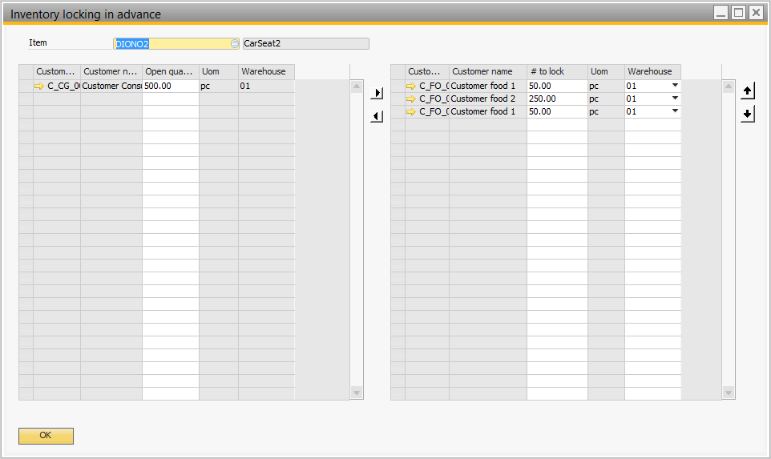

Outbound Logistics Processes
All WMS’ picking automation, workflow, and bulk processing are evolved from these four documents: SAP Sales Order, WMS Picklist Proposal, WMS Picklist, and SAP Delivery. Understanding these documents is the key to building effective outbound logistic processes.
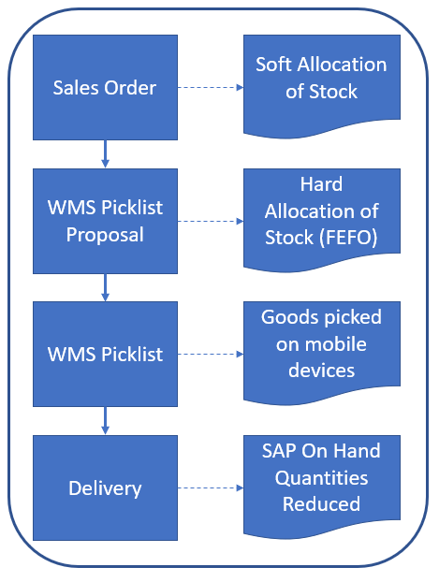

Sales Order à Picklist Generation
The outbound logistics process will be initiated through the Sales Order à Picklist Proposal à Generate Picklist flow. PDMX will allocate stock for Picklists based on the settings of the Extension Parameters “Picklist Proposal Generator” and “Picklist controller”.

The Picklist Proposal step will allow the warehouse manager/supervisor to monitor whether or not a Picklist could be fulfilled in accordance with the requirements of the customer. If need be, the warehouse manager/supervisor can also overrule the stock allocation for the customer. Until the moment warehouse manager/supervisor generates the actual Picklist, it will not be visible to the operators on the shop floor.

Order Picking

Picklist Proposal
[CUSTOMER] will generate WMS Picklist Proposals based upon the list of open Sales Orders. This list shows all open sales orders for which there is available stock. From this list, the warehouse manager / customer service team selects Sales Orders to be picked.

The Picklist Proposal is the first step in the outbound process. This document will allocate Batch-Tracked inventory at the Batch level according to the First Expiry First Out (FEFO) principle. Users can override this by allocating the Batch on the SAP Sales Order. If the item does not have an expiration date, then the allocation is based on the First In First Out (FIFO) principle.

The field ‘Pick and Pack Remarks’ can be used to add special instructions for the pickers. This is a standard B1 field on the Sales Order. Information in this field automatically flows to the Picklist Proposal, the Picklist, and then is visible on the mobile device.

In the open document report the warehouse manager can see all the Picklist Proposals in the system.

[CUSTOMER] will sometimes lock inventory for a specific customer. When the Picklist Proposal is created for that customer, the Picklist Proposal will use part of that inventory that was already locked for that BP.

Picklist
The second step is the Picklist. A Picklist is created based upon a Picklist Proposal. Once the Picklist is created it is visible in the handheld device. (Until the Picklist is created it is not visible in the scanner!)
During the picking process the user will scan the location where he or she picks the items from and scan the item barcode to identify the product that he/she is picking.

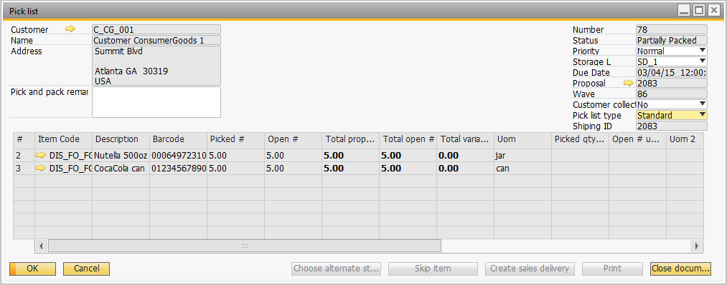

In the open document report for Picklist the warehouse manager has an overview of all the Picklist currently in the system. In this overview he/she will see that status of the Picklist, priority, who is working on the Picklist, the shipping type, customer…
From here the warehouse manager can open a Picklist and change the priority or the Picklist Type for example.

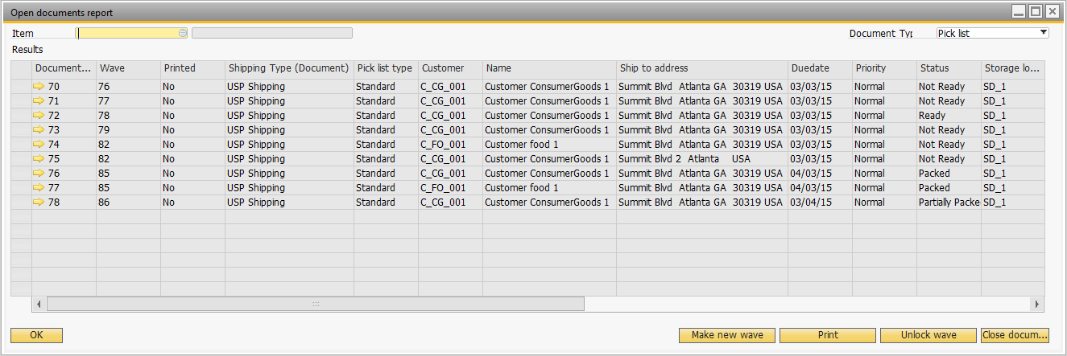

Picking Options
WMS has many picking workflow options that can be used for different customer shipping scenarios. Various combinations of these options can be used say for different customers or different types of orders (customer pick-up, delivery via own trucks, etc.)

This list summarizes some of the picking options:
- Order Picking – Pick the items on each Sales Order then create a Picklist fo the next Sales Order
- Wave Picking – Pick items from multiple Picklists in the same picking operation or wave
- Zone Picking – Create separate Picklists for items that are in different zones. Zones are used to group bins. Zone Picking would be used if different pickers can only access specific bins.
- Multi Picking – Allows several Picklists to be picked at the same time and brought to the packing line on a cart (or other movable location). Packing is done by the individual Picklist with the stock for each order pulled from the cart.
- Ad Hoc Picking – Similar to Order Picking, but no inventory allocation are created

Shipping Dock
[CUSTOMER] will have shipping docks as documented in Section 2.1 above. When the Picklist is created a default dock will be assigned to the Picklist by the system. If the Picklist needs to be shipped via another dock the warehouse manager will modify this field in the Picklist.

Picking
There will be 2 types of picking for [CUSTOMER]:
• Full pallet picking
• Item picking (by box or by bottle)

Full Pallet Picking
When the quantity ordered in the system is more or equal than the quantity of the product on a SSCC, then the system will suggest full pallet picking. In this case the user has to go to the bin location and scan the SSCC barcode.
Example: order quantity on sales order: 100 pieces
SSCC’s on in stock with each 25 pieces on. In this case the system will ask the user to scan 4 SSCC’s in order to complete the picking

Item Picking
When the quantity ordered in the system is less than the quantity of the product on a SSCC, the system will propose item picking. In this case the system will ask the user to scan the location, Scan the product and enter the quantity.
Remark: item picking can only be done when items are located on bins that are indicated as a pick location.

[CUSTOMER] will use 2 different functions in the scanner to do picking in Produmex:
- Picking
Picking will be used for the small order (‘mom and pap’ customers). The Picklists for these customers will be grouped in a wave and picked with the ‘picking’ functionality and they will be picked in a moveable location (cart).
Later on these orders are sorted out on the packing station (see packing)
- Ad hoc picking
Ad hoc picking will be used for the majority of the orders. Because [CUSTOMER] has a lot of floor locations and not always the oldest pallet will sit in the front. With ad hoc picking there is the flexibility to let the user pick the pallet in front of the row instead of at the end of the location.

Picking Example
Below is an example of the picking flow on the mobile device. This is an example only and the steps may vary based upon item, BP master setup.

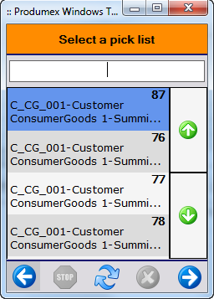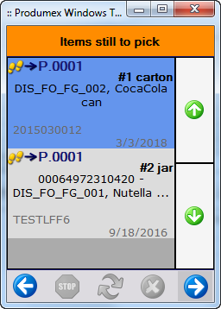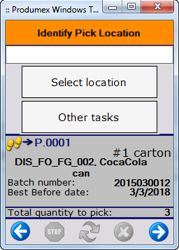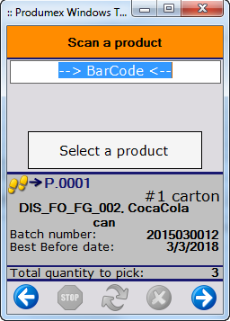

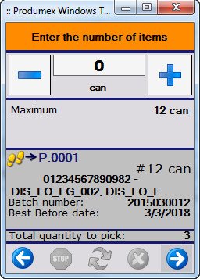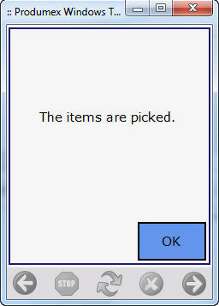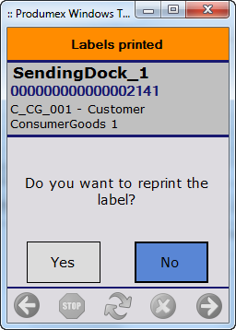

Packing
[CUSTOMER] will use the packing step for the orders that are wave-picked on a moveable location (cart).

After scanning the moveable location the packing list will show a list of all the customer where you need to ship to. After that the user will be packing each order individually. After packing for an order the packed SSCC will be moved to the shipping dock waiting to be loaded into the truck.
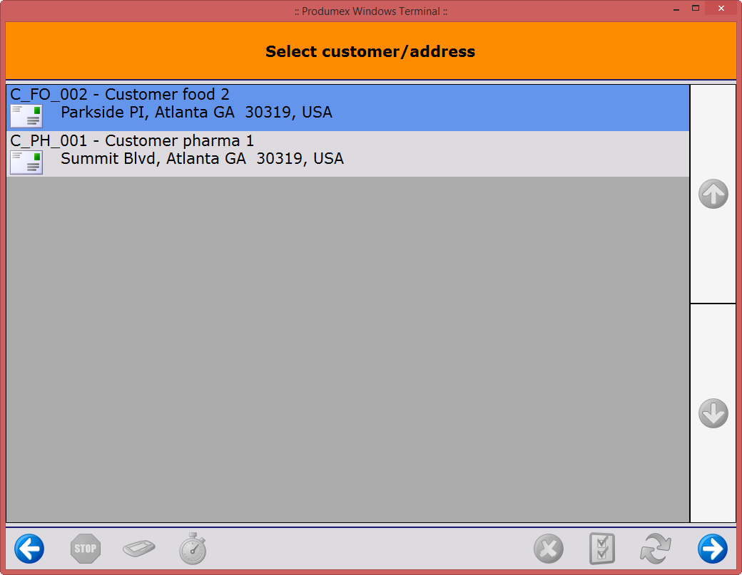
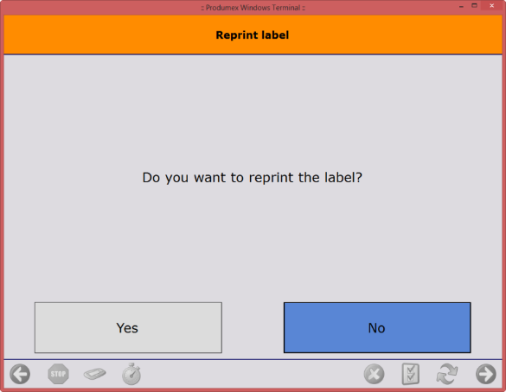
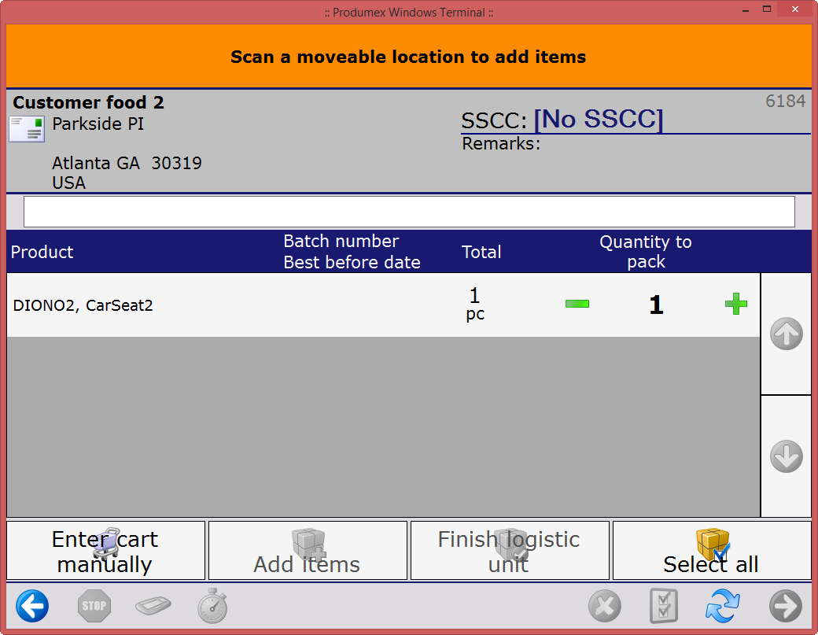

Delivery and Shipping
The WMS Shipping function on the mobile device is used when the picked and packed goods are loaded onto the truck. If these goods need to be processed by the carrier’s shipping systems (i.e. UPS World Ship) then the WMS Shipping function can be performed earlier so that the SAP Delivery data is available to the shipping system.

The pallets will first be stored in the staging area in front of the shipping dock. When the trucks arrive, the pallets will be loaded into the truck and a delivery note will be created.

At a later stage [CUSTOMER] would like to record properties like track number, license plate, trailer number, driver. These can be enabled or disabled at all times and are linked to the shipping type that is setup on the sales order.

Traceability
Produmex has a standard traceability report and can be used to perform backward and forward traceability analysis. The backward traceability is used to start tracing from a finished product to the raw materials. The forward traceability works the other way.

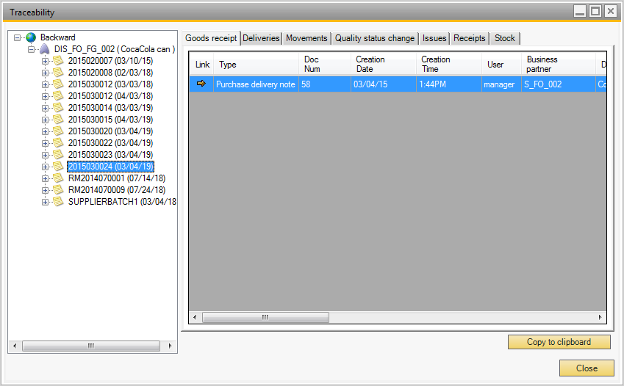

Returns

Sales Returns
Sales returns (returns from customers) can be entered by using the mobile device or can be added by using the default SAP screen.

When adding a sales return, the operator first has to select the customer from which the sales return is received.

As long as no A/R invoice has been made, a sales return can be made against a specific delivery. If an A/R invoice has already been created, it is not possible anymore to select a specific delivery and then the operator will have to select “No delivery” on the mobile device.

If the default SAP screen is used, the system will require some additional information on row level such as (bin location, Quality Status, Batch 1, Batch2, …)

Purchase Returns
Purchase returns (returns to suppliers) can be entered by using the mobile device or can be added by using the default SAP screen.

When adding a purchase return, the operator first selects the supplier to which the purchase return is sent.

If no A/P invoice has been made, a purchase return can be made against a specific delivery. If an A/P invoice has already been created, it is not possible anymore to select a specific delivery and then the operator will have to select “No delivery” on the mobile device.

If the default SAP screen is used, the system will require some additional information on row level such as (bin location, Quality Status, Batch 1, Batch2, …)

Production

SAP Bills of Material
WMS Production uses the SAP Issue Method of Manual for all raw materials. Bills of Material (BOMs) that have Backflush components must be changed to Manual.

SAP Production Orders
SAP Production Orders are created using the standard SAP tools (Production Order screen, Procurement Confirmation Wizard, etc.) The WMS Production Line must be set to the Production Order header. WMS processes Production Orders with a Status of Released.

WMS Production Processing

Picking Raw Materials
WMS Picklists can be created to bring raw materials to the Production Line or picking for production can be on a ad-hoc basis

Lined Up Raw Materials
Certain raw materials can be configured as Lined Up, meaning that the item will ‘flow’ into production instead of requiring a separate WMS transaction to access the inventory. WMS consumes these items as it receives finished goods into inventory. The quantity of lined up items consumed is set to the quantity indicated in the Production Order. WMS stores lined up materials in Tanks (Silos) which are defined in the OSE.

Weighing Raw Materials
Certain raw materials can be configured as requiring weighing. A WMS Weight Order will be created to have these materials weighed before that can be consumed during production.

Optional WMS Production Steps
- Labels may be configured to automatically print for finished goods as they are received into inventory.
- Finished goods may be put on pallets (SSCCs)
- Production Orders may be put on hold
- Waste raw materials may be recorded for each Production Order
- WMS can generate Batch Numbers and Serial Numbers for finished goods as they are received from production
- The default Quality Status can be set on the finished good’s Item Master record to facility a testing step

WMS Default Reports
WMS includes a set of reports that can be adapted to [CUSTOMER]’s requirements. These include:
- Goods Receipt Pallet Label
  - SSCC pallet label for reception
- Item label
  - This label identifies the item. It typically contains the Item Code, Item Description, and the Item’s GTIN, all in human-readable form, plus a barcode of the GTIN or Item Code
  - The WMS option to print this label is used for items that don’t come with a barcoded label
- Picklist
  - Picklist forms can be used if desired
- Shipping Carton Labels
  - Shipping Carton Labels are used when an SSCC is required for shipping boxes that are ready for shipment
- Shipping Pallet Labels
  - Shipping Pallet Labels are used when an SSCC is required for shipping pallets which contain multiple shipping cartons. These pallets are ready for shipment
- Sales Delivery Note
  - Packing list for all the items on a shipment

If creation of customer-specific layouts is needed, then report modification services can be offered on a time and material basis.

Data Conversion Strategy

Organizational Structure Data
The WMS Import Tool is used to import certain components in the WMS Organizational Structure from spreadsheets / CSV files. These include:
- Bins
- Zones

Organizational Structure Settings
The WMS Import Tool is used to copy most settings in the WMS Organizational Structure from one database to another. These settings include data on the following OSE tabs:
- General
- Defaults
- Extension Parameter
- 3PL Invoicing
- Quality Status

WMS Extended Data
WMS extended data includes information such as Allergens, Container Shipping Statuses, Batch Attributes, Picklist Types, and Expiry Definitions. This data is maintained manually through screens on the SAP Tools à Default Forms menu. Any need to add / update WMS Extended Data is indicated as it occurs throughout this document.

WMS Extensions for SAP Master Data
WMS extensions for SAP Item Master Data and Business Partner Master Data consist of the data on the Produmex tabs, or one of its sub-tabs, that exists at the same level as the SAP Master Data. This data can be imported as follows:
- Regenerate the DTW import templates for the Item Master (OITM) and Business Partner Master (OCRD)
- Determine which fields need to be populated as indicated in the respective sections of this Blueprint Document
- Use your site procedures for using DTW to update the WMS data in the SAP Master Data

WMS Data Linked to SAP Master Data
WMS Data Linked to SAP Master Data is the multi-level data which typically appears as grids on the Produmex tabs, or one of its sub-tabs.

The WMS Import Tool is used to import WMS linked to SAP Master Data from spreadsheets / CSV files. All referenced data must exist before performing this import. This data includes:
- Item / Bin
- BP / Item Shelf Life
- Item / Zone Types
- Item / Packaging Types
- Item / Batch Attributes
- Item / Allergens
- Item / Warehouse / Default Zone
- Item / BP / Quality Status

SAP Inventory On-Hand Quantities (Stock Counts)
The WMS Initial Stock Import Tool can be used when all of the following are true:
- Stock exists in an SAP Warehouse
- The SAP Warehouse does not use SAP Bins
- No serial tracked items exist in the warehouse to be converted

In most other cases SAP Inventory on-hand quantities are imported into Goods Issue documents using SAP’s DTW. The DTW Templates for the document to be imported must be regenerated using DTW’s Generate UDF Templates function on the Templates menu. Then these templates are populated; WMS-specific fields must also be populated. These include:
- U_PMX_LOCO -> set to the location code of the conversion bin - Required
- U_PMX_QYSC -> for the quality status (typical value: RELEASED) - Required
- U_PMX_LUID -> set to -1 for a new SSCC per line
- U_PMX_SSCC -> set to an existing SSCC if applicable

This article provides detailed information on this process: https://support.boyum-it.com/hc/en-us/articles/360015202617-How-to-Import-Stock-Quantities-into-WMS

Implementation outline
Produmex follows the SAP Implementation Methodology in conjunction with our SAP Business One Partner.

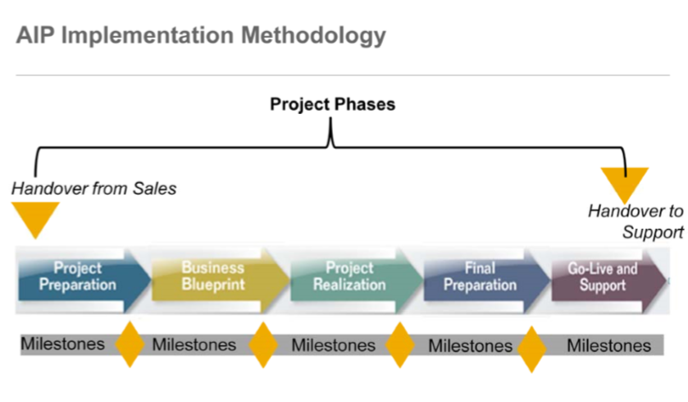

Change Requests
Based on our discussion, please find below the list of topics that can be considered as change requests.
Change requests involve specific modifications to the standard WMS product for [CUSTOMER]. Boyum will estimate the effort required for these changes and propose a specific budget for their realization.

IMPORTANT: This does not include report or label changes which are done in Crystal Reports.

[CUSTOMER] is requested to indicate which of the following change requests should be estimated by Boyum.

Reference | Subject | Description | Estimated Cost
1
2
3

Implementation Plan
This plan is an estimate of the workload; it is not a fixed budget. When this Blueprint is approved then the tasks below will be included into a Statement of Work for project realization.

Implementation Function | Description | Responsibility | Estimated Days
WMS Configuration
- Install WMS software | Installation of the WMS software | Boyum | 1
- Setup / import and test OSE | [CUSTOMER] to provide bulk data such as bins. Sections 7.1 and 7.2 | Boyum | 2
- Setup / import and test WMS Master Data extension* | Sections 7.3, 7.4, and 7.5 above | [CUSTOMER] | 2
- Create and test inventory quantity import procedure* | Section 7.6 above | Boyum / [CUSTOMER] / [PARTNER] | 2
- Label/report modifications* | Receiving labels, packing labels, picklists, ... | Boyum / [CUSTOMER] / [PARTNER] | TBD
- Business process documentation | All primary business processes | Boyum | 4
- Change Requests (Section 9)
Hardware Configuration | Scanners, touchscreens, printers, site survey | Boyum / [CUSTOMER] / [PARTNER] | 1
Warehouse Process Development | Warehouse Process Flows
- Inbound processes | Receiving, put away, purchase returns, ... | Boyum | 2
- Outbound processes | Pick, Pack, Ship | Boyum | 2
- Inventory processes | Moves, Cycle counts, inventory management | Boyum | 2
- Production processes |  | Boyum | 2
User Acceptance testing
- Build UAT Database |  | [PARTNER] and Boyum | 3
- Test UAT/TEST scenarios |  | [CUSTOMER] and Boyum | 3
Go live | Data migrations / go live support
- Go-Live preparations |  | [PARTNER] / Boyum | 2
- Go-Live Assistance |  | [PARTNER] / [CUSTOMER] | 2
Project management + Q&A |  | Boyum | 1
Totals |  |  | 27

* - Estimates with * are subject to change as additional information becomes available

test scenarios

Project plan
Following the acceptance of this blueprint, [CUSTOMER] will draw up a detailed project plan for the execution of the Produmex WMS for SAP Business One implementation.

Testing procedures
Boyum IT Solutions requires from [CUSTOMER] to create a test plan with test scenarios. The test plan will contain all the test scenarios and they must be executed successfully and validated before go-live.
The test scenarios will represent all the flows that are in scope of the project.

After the test plan is created, the team will review the test plan and correct/validate if necessary.
The test scenarios described in the test plan must be executed by [CUSTOMER] which will ensure that all the processes used by [CUSTOMER] are tested and in line with the expectations of [CUSTOMER].
Therefore, it is important that the test plan must be finished before the start of user acceptance testing.

If there are problems after go-live that are part of the test scenarios, Boyum IT will bill all the time required to resolve the problem. Problems that arise and that are not part of the test scenarios are considered out of scope and will be treated as a scope deviation. The purpose of these test protocols is a smooth go-live by having all processes tested and having all key-users well-trained

commercial conditions
Period of validity quotation

1 month from date of quotation.

Terms of payment

Our invoices are payable 30 days from the date of invoice.

The payment schedule is as follows:

Change requests items | 50 % at order, 50 % at delivery
Licenses | 100 % at order
Services | 2-weekly based on service sheets
Hardware | 80 % at order, 20 % at delivery
Maintenance | 100 % at order of licenses

Our prices are calculated excluding VAT.

For delivery and performance our general terms and conditions apply. They can be downloaded from our website.

approval
Recognized and accepted:

For Company name |  | For Boyum IT Solutions
Signature |  | Signature
Name: |  | Name:
Title: |  | Title:
Date:

Appendix 1 – GS1 Standards

GTIN and SSCC
The two main GS1 identification keys are
- GTIN – Global Trade Item Number
- SSCC – Serial Shipment Container Code

The GTIN uniquely identifies a trade item. This can be a single product (e.g. a can of beer) or a standard grouping of products (e.g. a six-pack of beer). The principle for assigning a GTIN to a product or a standard grouping of products is the fact whether it can be treated as a single trade item between supply chain partners, be it in Business-to-Consumer relations in retail or in Business-to-Business relations in manufacturing, wholesale and trade.

The GTIN identifies on the one hand the company that brings the product to market and on the other hand assigns a unique number to the product within the product range of the company.

The SSCC uniquely identifies an individual logistic unit that is composed for transport & storage, which has to be managed throughout the supply chain. The SSCC identifies on the one hand the organization that prepares the logistics unit. This can be:
- The manufacturer
- The wholesaler
- The logistics provider
- The distributor

On the other hand, the SSCC assigns a unique number to each individually prepared logistic unit based on a range of numbers purchased by the organization that assigns the SSCC
- The SSCC is the key element for traceability
- The SSCC allows to find traceability data about product batches that have been stored in databases.
- The SSCC allows to establish the link between the physical goods flow (logistic units that are ready for shipping, in stock, delivered …) and the associated information flow (delivery documents or electronic messages).

Apart from the SSCC and GTIN, GS1 has defined two additional identification keys which are less commonly used:
- GLN – the Global Location Number, uniquely identifying a production or distribution site
- GRAI – the Global Returnable Asset Identifier, to identify logistic carriers

GS1 Label
The GS1 logistics label is a standard format for identifying Logistic Units – SSCCs (Serial Shipment Container Code). Please refer to the GS1 guidelines for information about its format and characteristics.
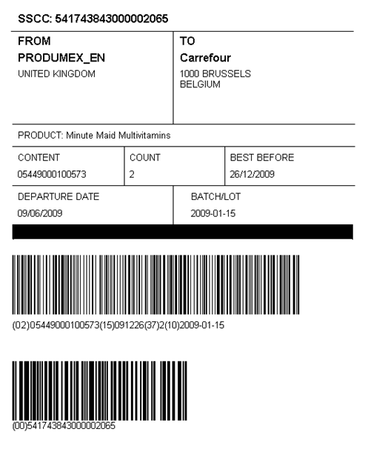

GS1-128 Barcode
GS1-128 is the GS1 standard for using the code 128 barcode specification. GS1-128 consists of application identifiers (AI) such as:
- SSCC
- GTIN
- (10) batch number
- (15) best before date

Overview of different Application Identifiers (AI)
AI | Description | Data Format
00 | Serial Shipping Container Code (SSCC-18) | 18 digits - numeric
01 | Shipping Container Code (SSC) | 14 digits - numeric
02 | Number of containers | 14 digits - numeric
10 | Batch Number | 1-20 alphanumeric
11 | Production Date | 6 digits: YYMMDD
13 | Packaging Date | 6 digits: YYMMDD
15 | Sell by Date (Quality Control) | 6 digits: YYMMDD
17 | Expiration Date | 6 digits: YYMMDD
20 | Product Variant | 2 digits
21 | Serial Number | 1-20 alphanumeric
31nn - 36nn | Different measurements | 6 digits
37 | Number of Units Contained | 1-8 digits
400 | Customer Purchase Order Number | 1-29 alphanumeric
410 | Ship To/Deliver To Location Code (EAN13 or DUNS code) | 13 digits
411 | Bill To/Invoice Location Code (EAN13 or DUNS code) | 13 digits
412 | Purchase From Location Code (EAN13 or DUNS code) | 13 digits
420 | Ship To/Deliver To Postal Code (Single Postal Authority) | 1-9 alphanumeric
421 | Ship To/Deliver To Postal Code (Multiple Postal Authority) | 4-12 alphanumeric
90 | Mutually Agreed Between Trading Partners | 1-30 alphanumeric
91 - 99 | Company Internal Information | 1-30 alphanumeric

Example GS1 128 barcodes:

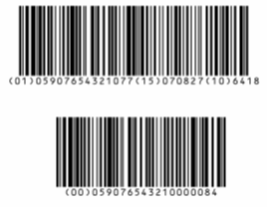

The first barcode (01)05907654321077(15)070827(10)6418 has 3 AI:
- (01)05907654321077 -> GTIN of the item
- (15)070827 -> Expiry date
- (10)6418 -> Batch number

The second barcode (00)059076543210000084 has 1 AI:
- (00)059076543210000084 -> SSCC: The SSCC of this logistic unit is 059076543210000084.

SSCC
The Serial Shipping Container Code (SSCC) is the unique number for a Logistic Unit (pallet, container, box, etc.). It consists of 18 characters. The SSCC can be a part of a GS1-128 barcode.

GTIN
GTIN (Global Trade Item Number). This is a unique number for a trade item (article). It can consist of 8, 12, 13 or 14 figures. The GTIN is still widely known as EAN (European Article Number) 8, 12, 13 or 14.

Most products of [CUSTOMER] have UPC (12 digits) as a barcode except for the inner and outer cartons, those are GTIN14. UPC-12 is compatible with GTIN14 if you add 2 leading zeros.

Appendix 2 – Produmex WMS Process flowcharts

Inbound Logistics

Reception Flow
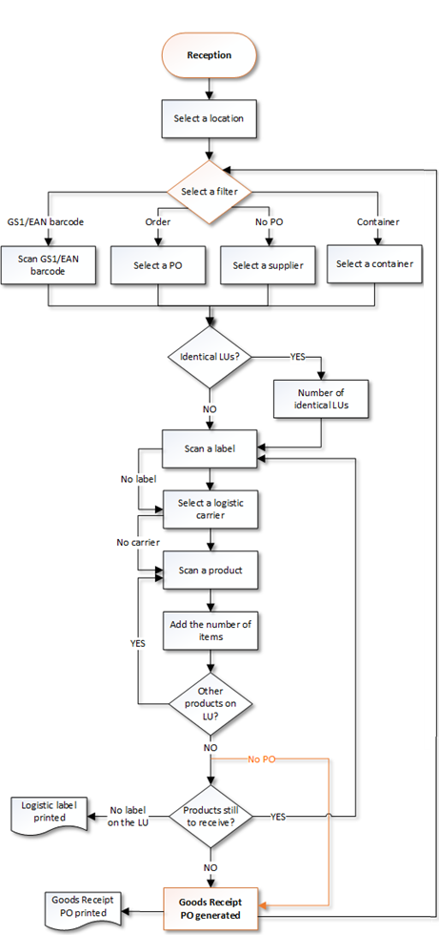

Put-away flow
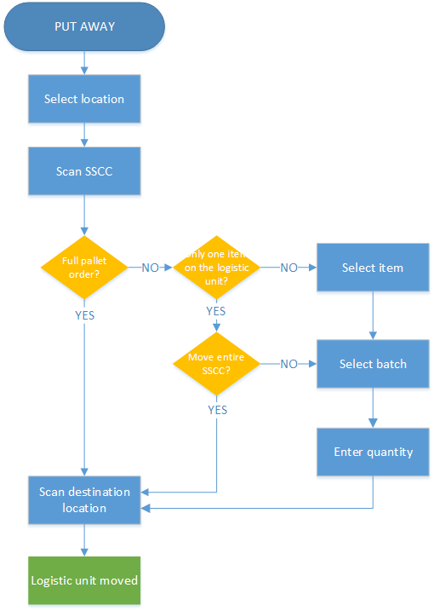

Bulk Reception Flow
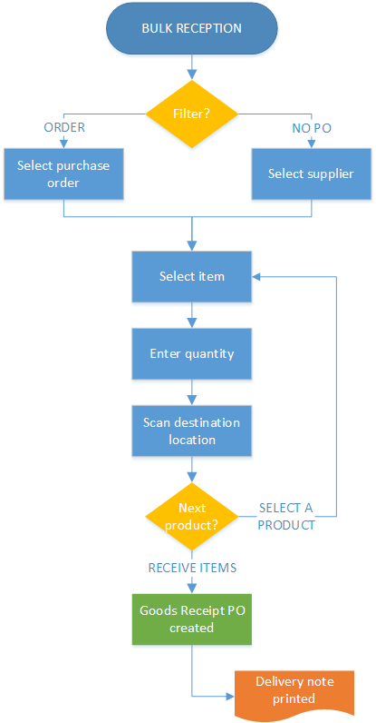

ASN Reception Flow

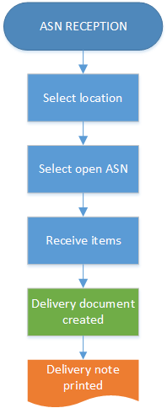

Create Purchase Document Flow
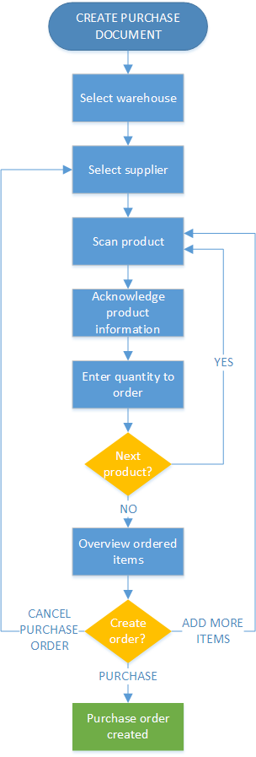

Receive from Warehouse Flow
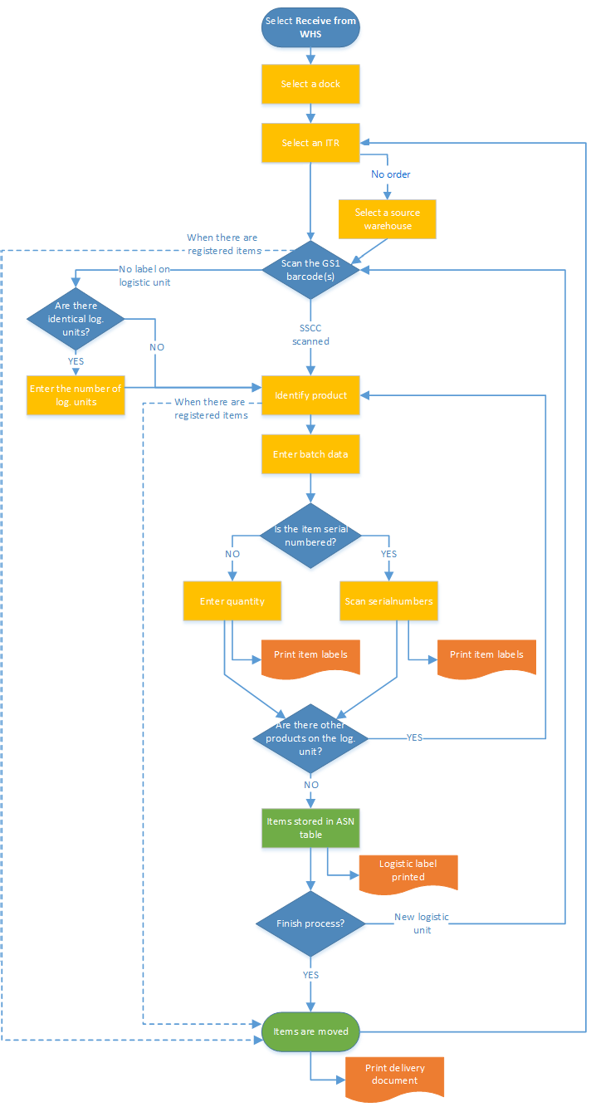

Sales Return Flow
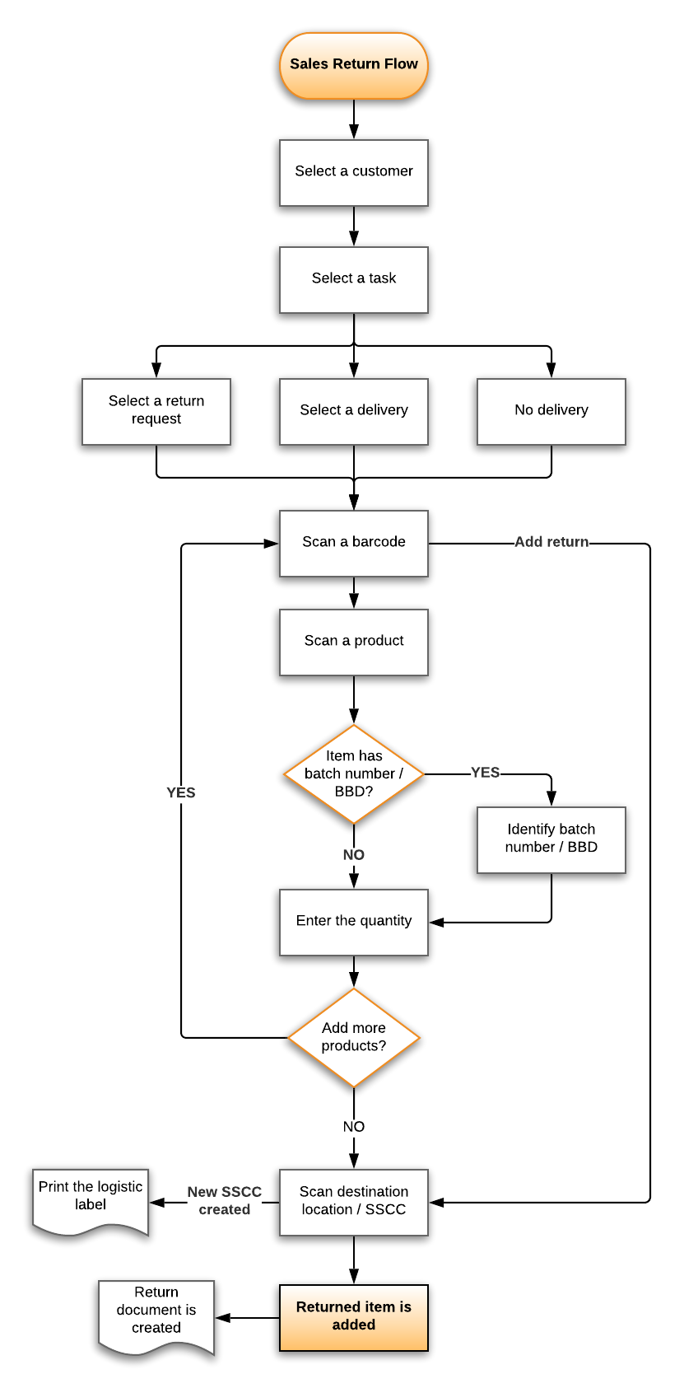

Outbound Logistics

Purchase Return Flow
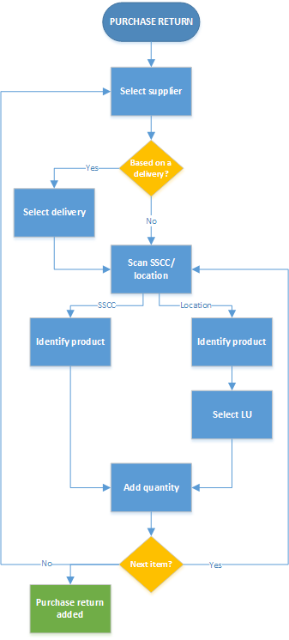

Picking Flow
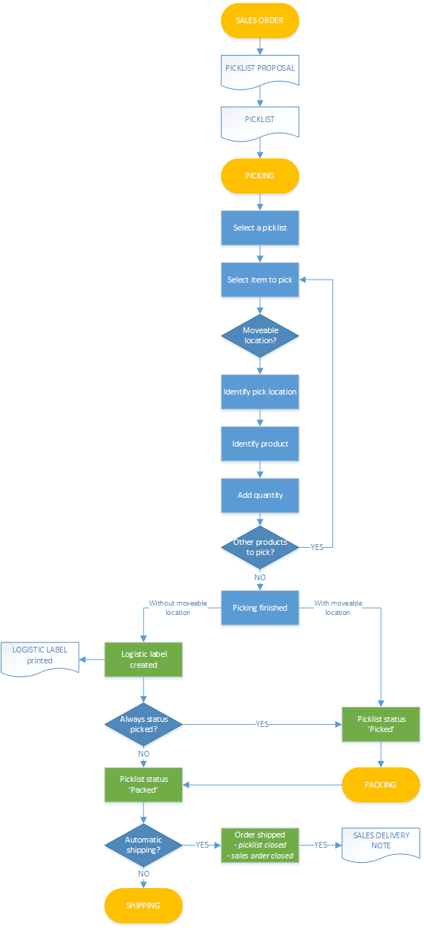

Multi-picking Flow
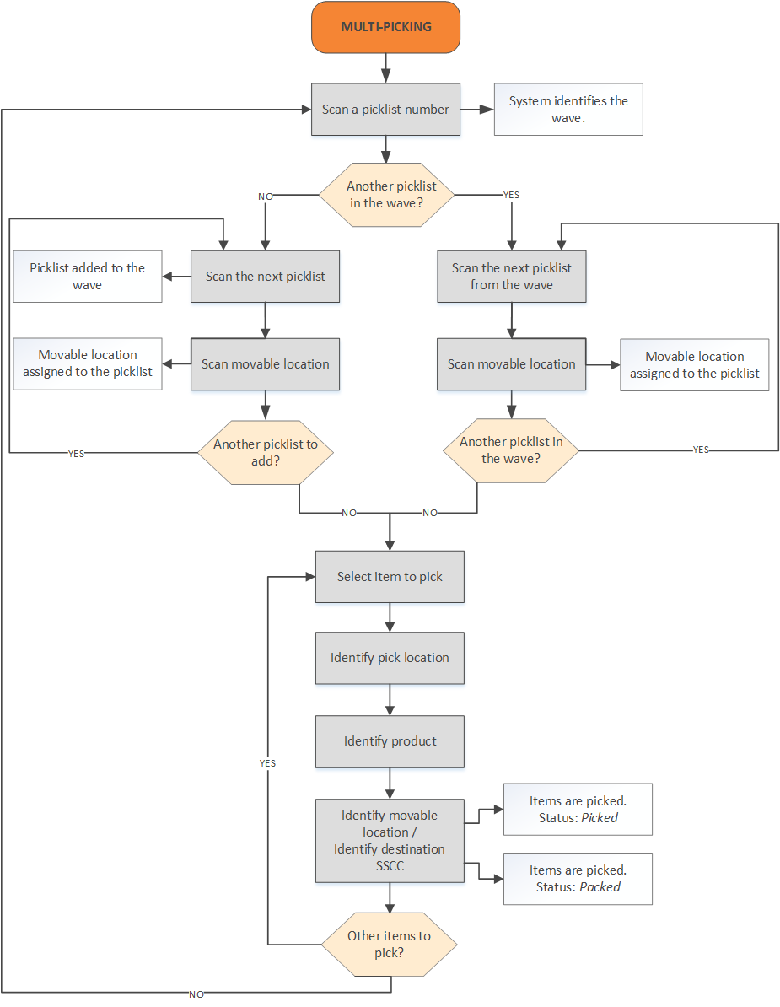

Zone-picking Flow
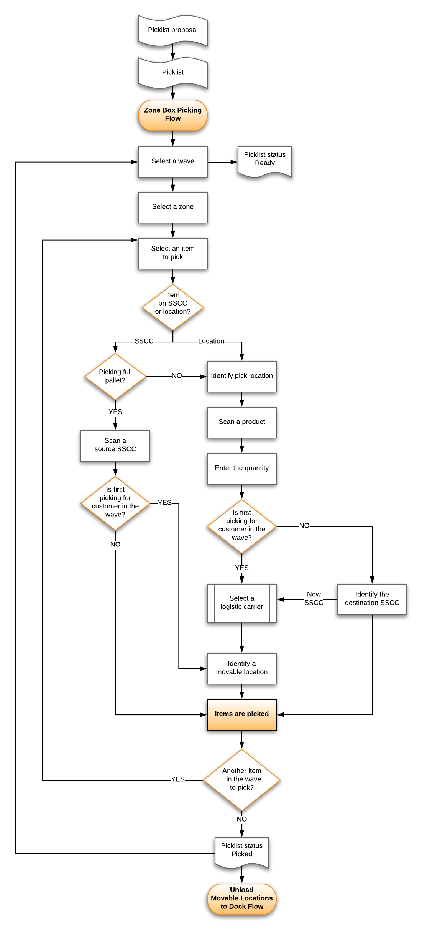

Ad-hoc Picking Flow
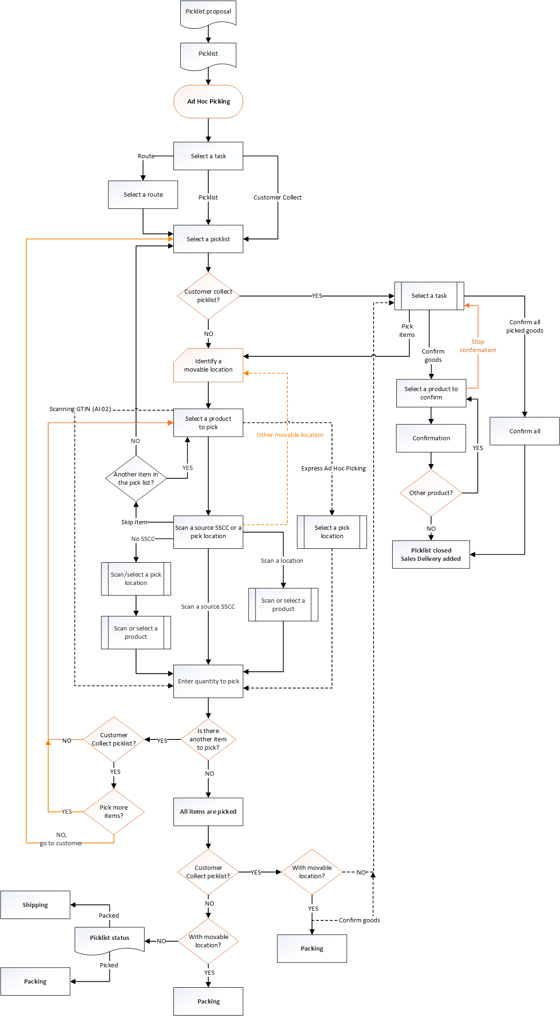

Packing Flow
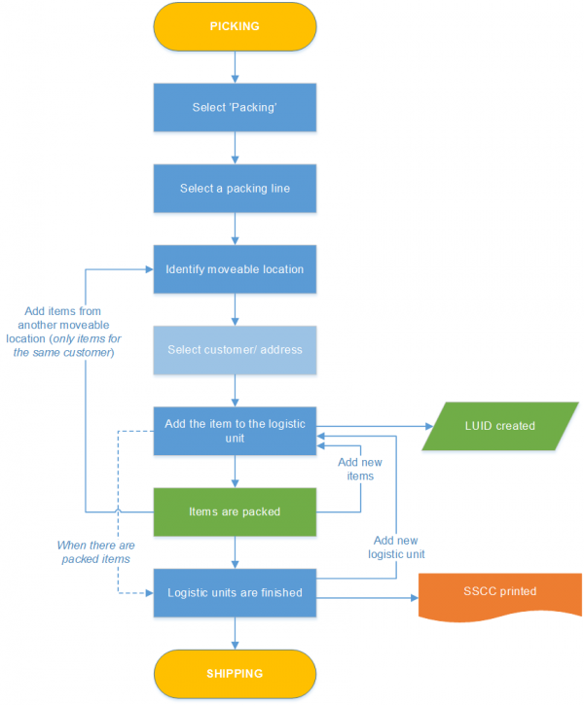

Mobile Packing Flow

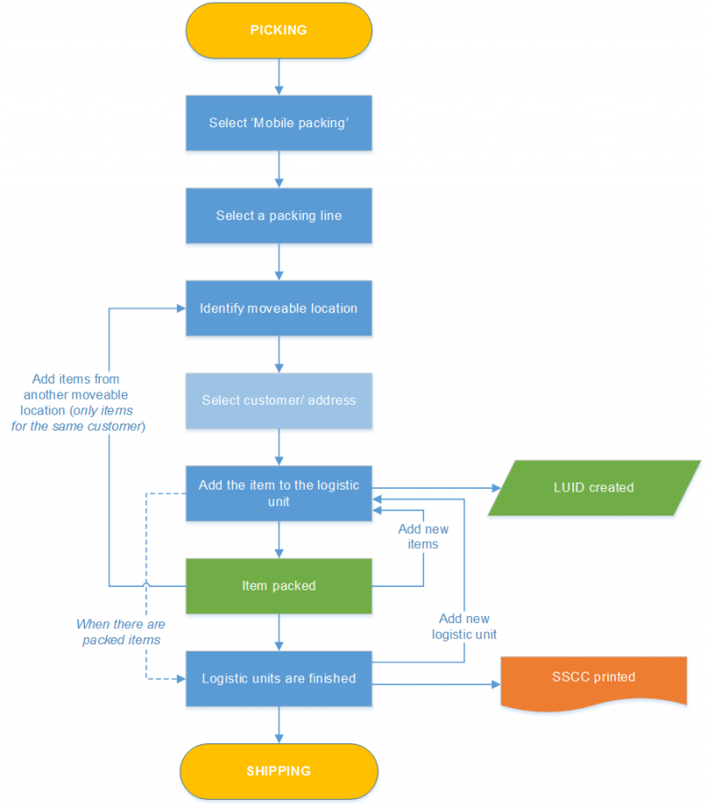

Item Packing Flow
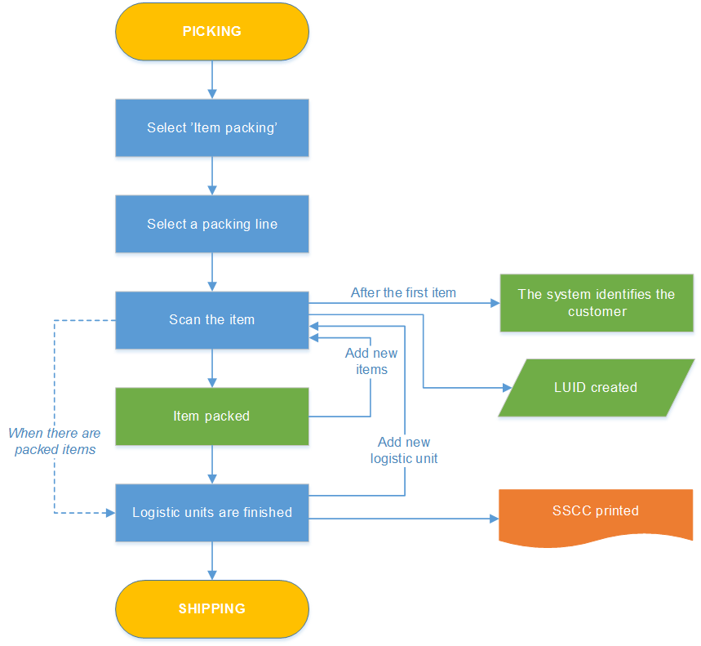

Consolidated Packing Flow
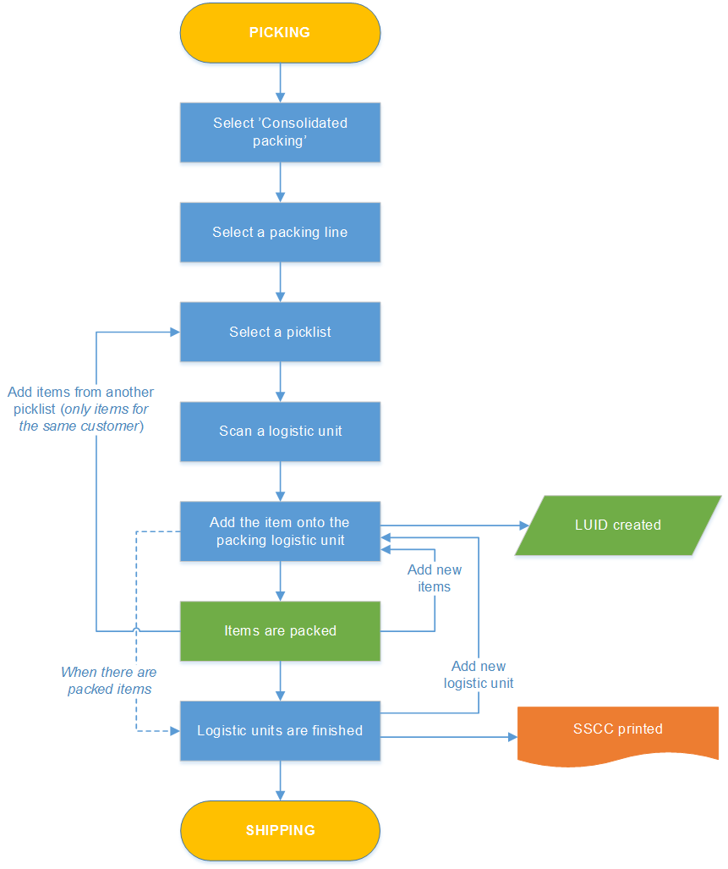

Box Pick-Pack Flow
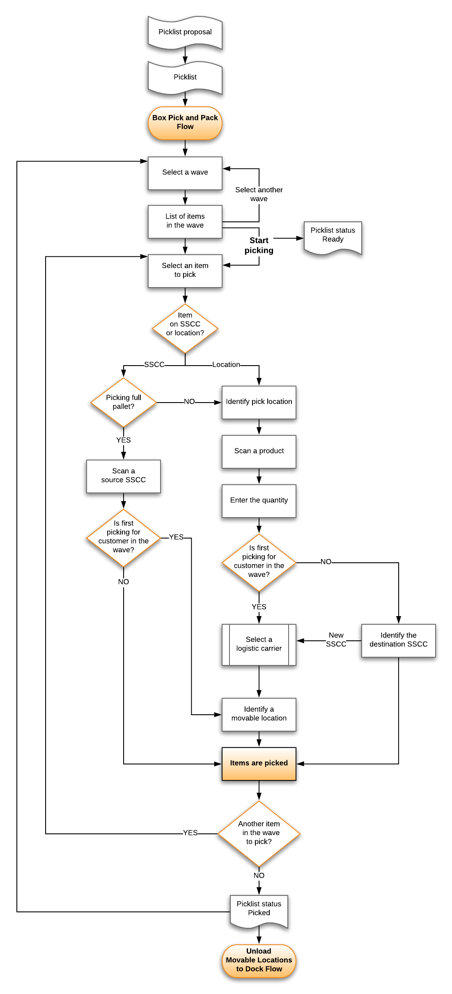

Prepare Carts Flow
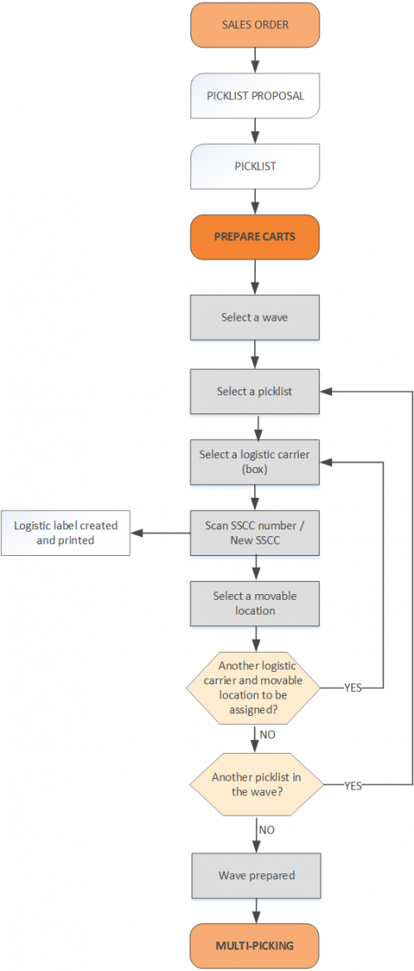

Cash Register Packing Flow
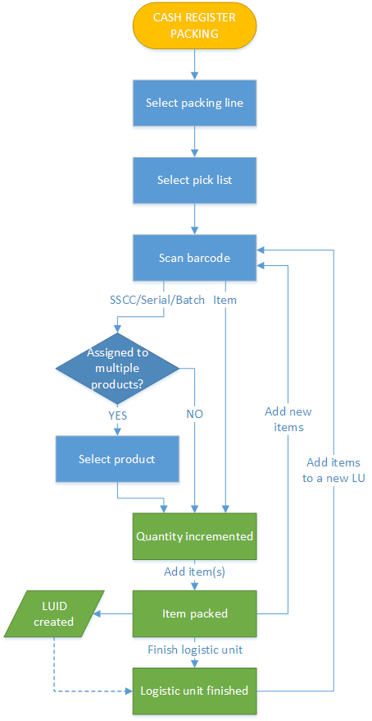

Unload Movable Locations to Docks Flow
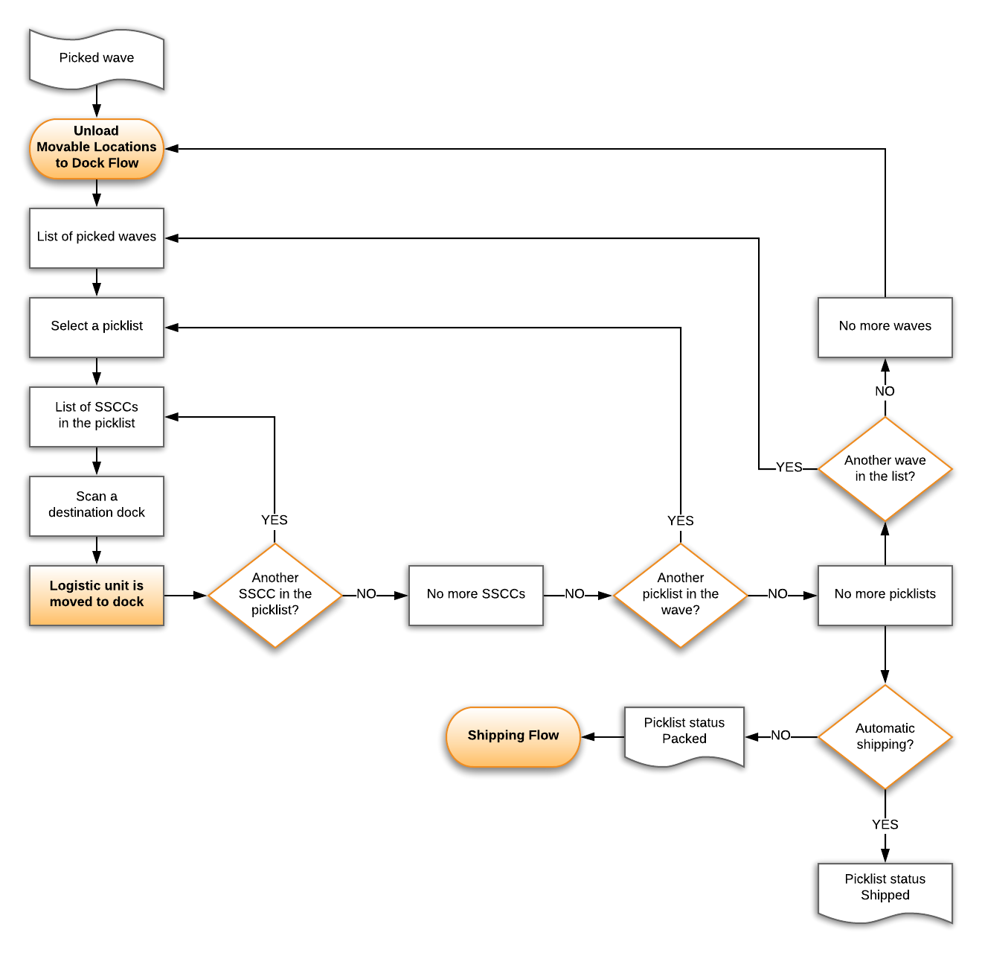

Shipping Flow

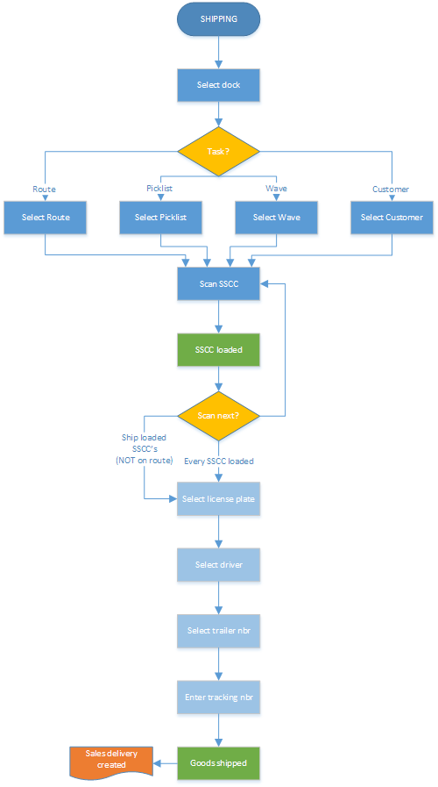

Cross Docking Flow
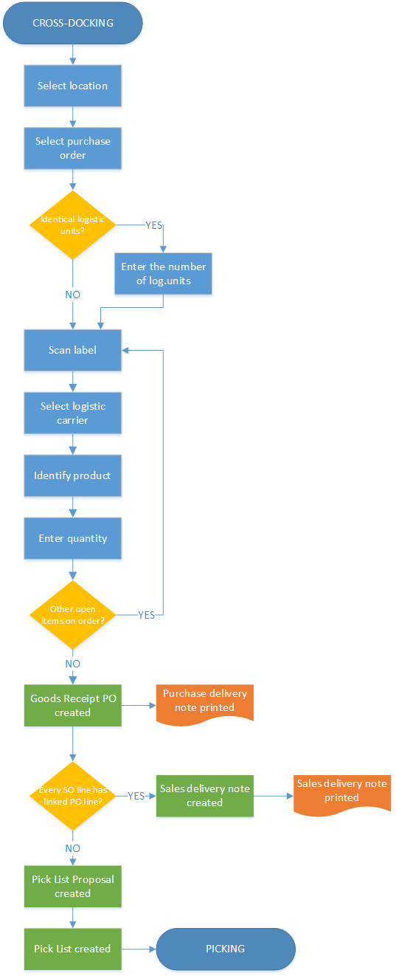

Internal Logistics

Ad-Hoc Movements Flow
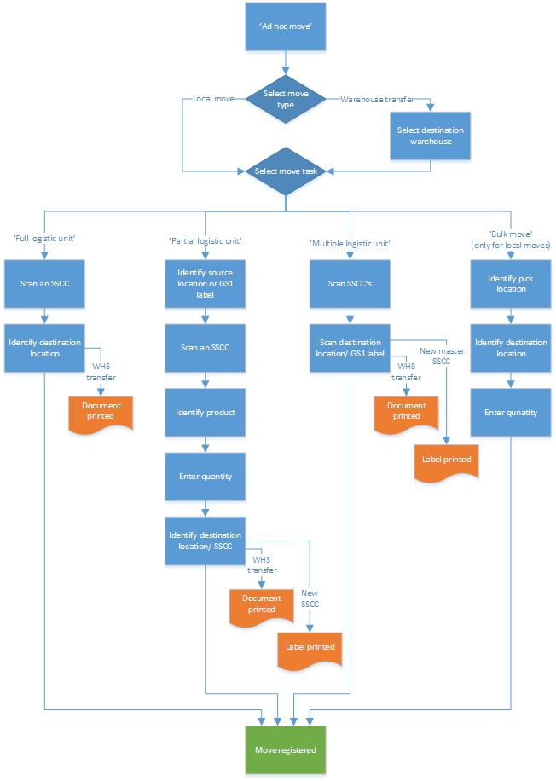

Move Orders Flow
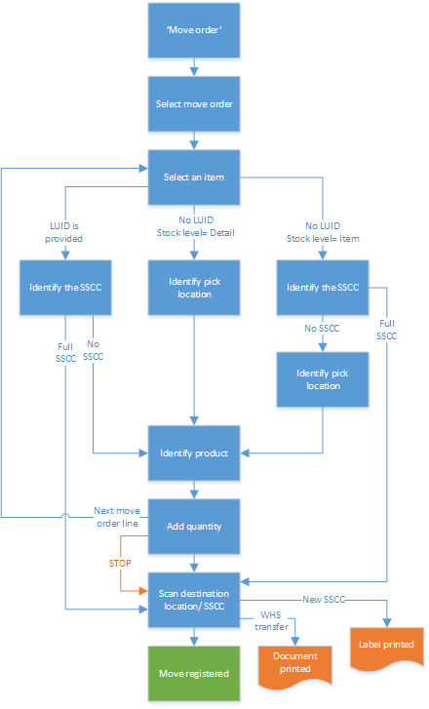

Consolidated Move Flow
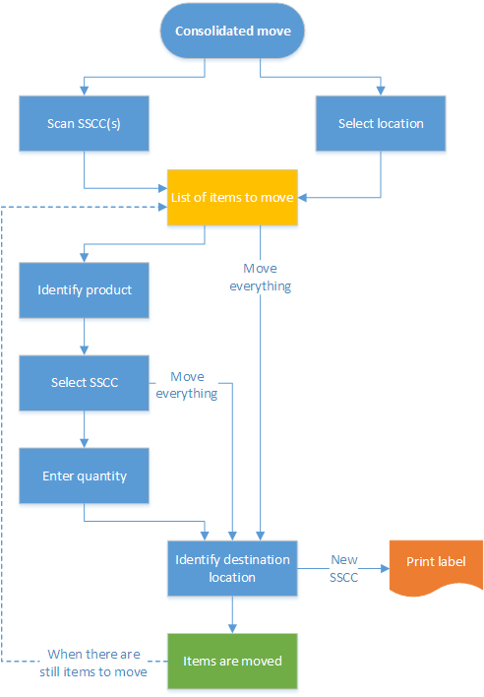

Replenishment Flow
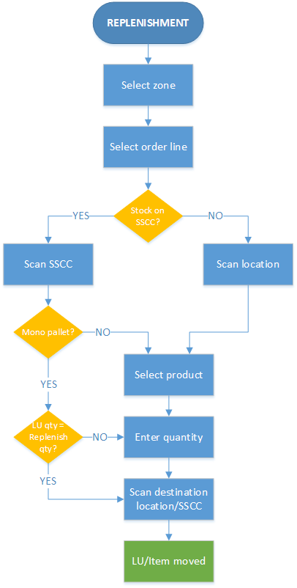

Cycle Count Flow
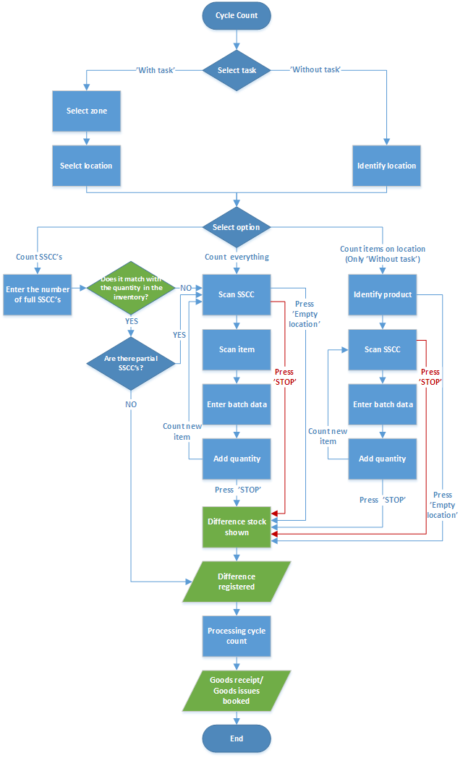

Undo Picking Flow
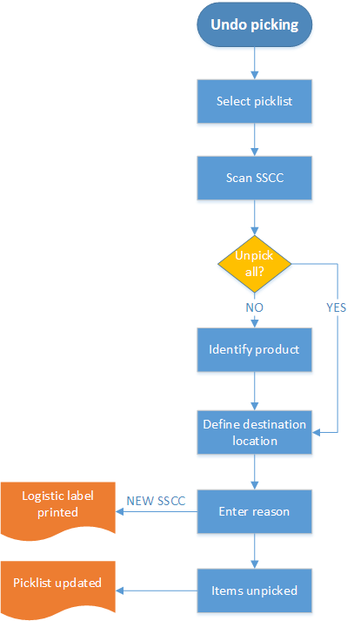

Production Logistics Flows

Picking for Production Flow
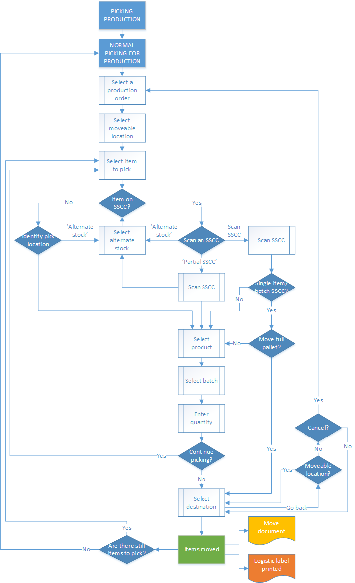

Picklist for Production Flow
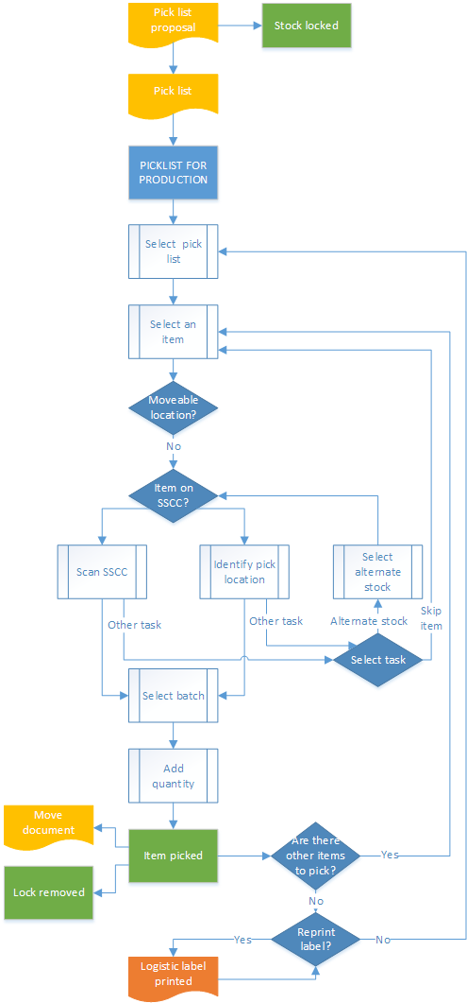

Unpicking for Production Flow
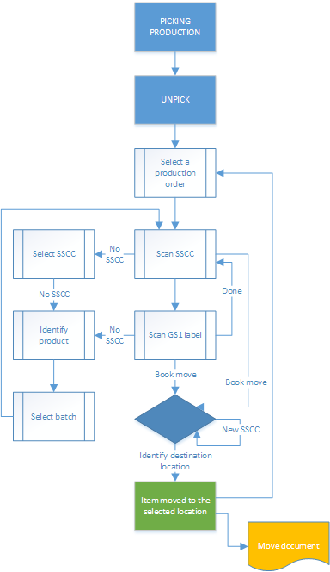

Move Components to Production Line Flow
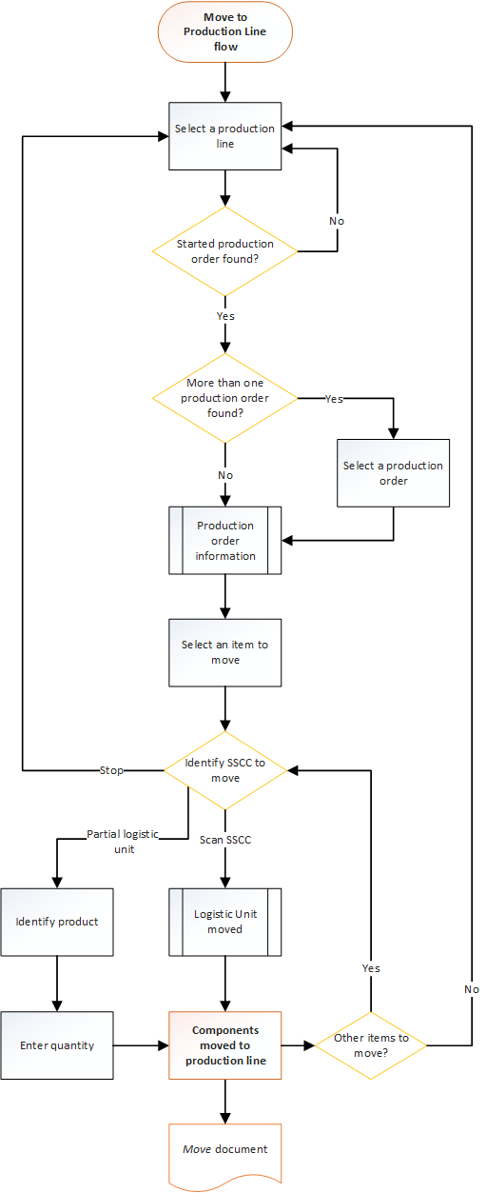

Component Weighing for Production Flow
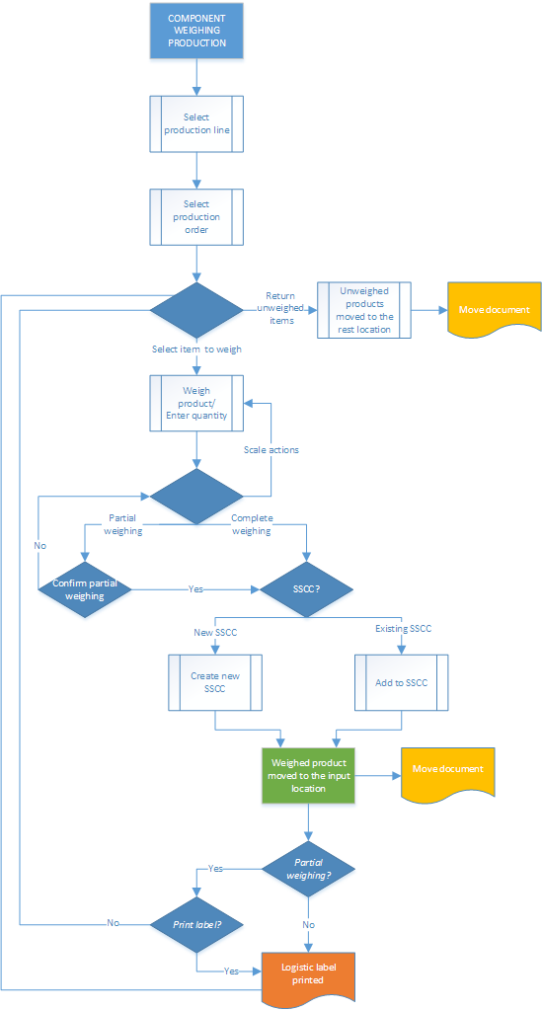

Production Flow
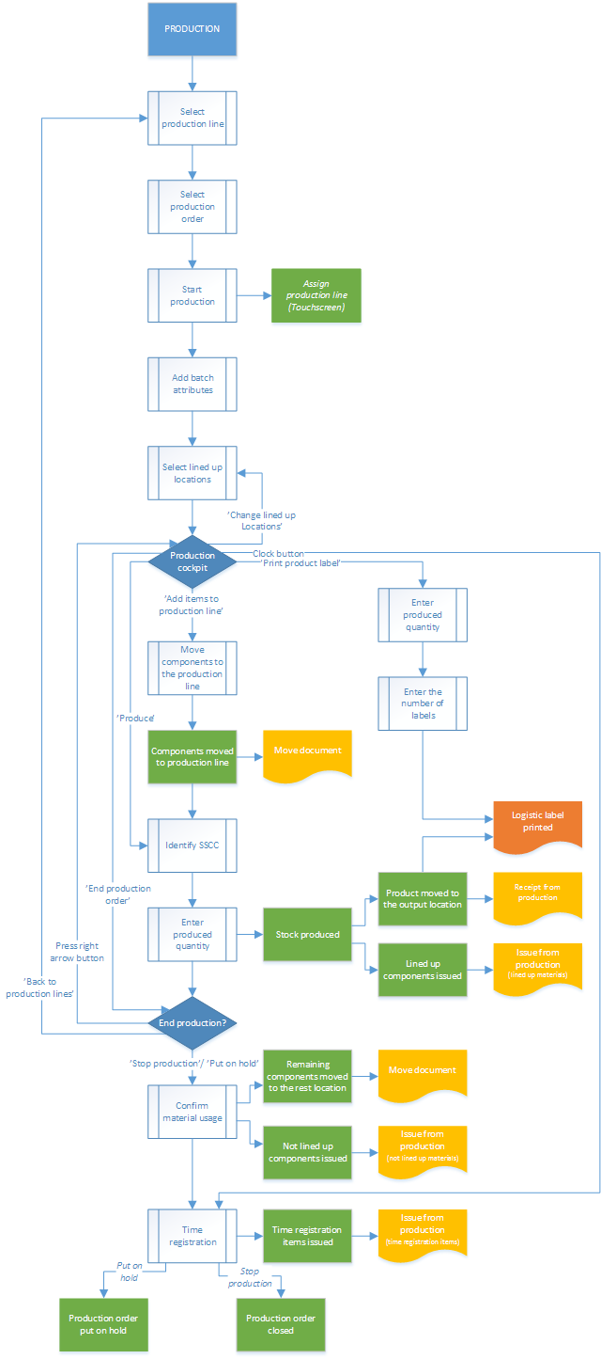

Production Disassembly Flow
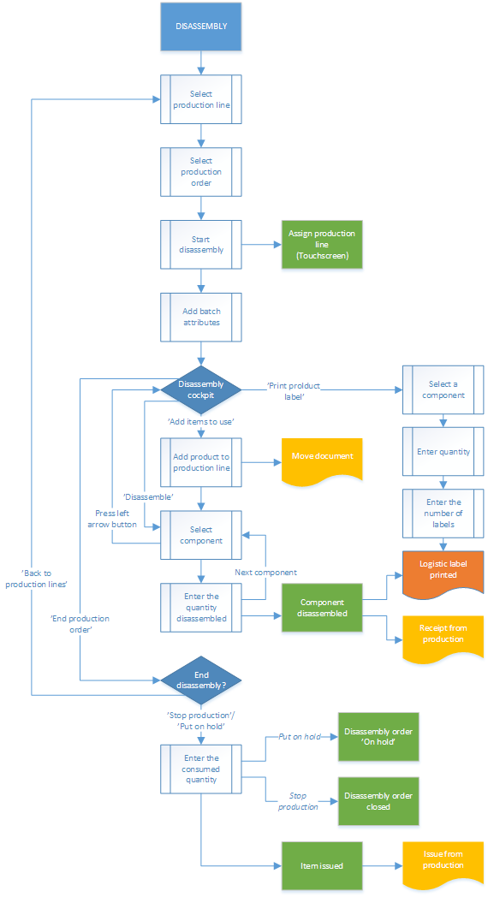

Receipt from Production Flow
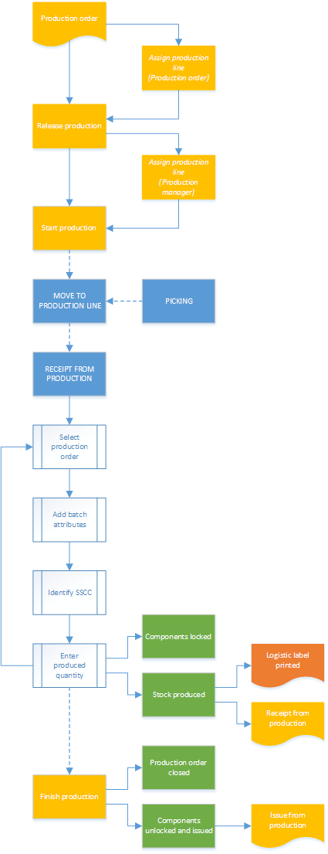

Boyum IT - Industry leading solution provider
Boyum IT is the largest and best-known global software solution partner for SAP Business One. We are a member
of the SAP Partner Solution Council and have been honored to have received more than 20 SAP awards. Among
these are the SAP Global Solution of the Year Award and People’s Choice Award, which we received the last 3
years in a row. We have the largest partner and customer ecosystems, with a presence in more than 100 countries and over 8,000 customers and 185,000 users.

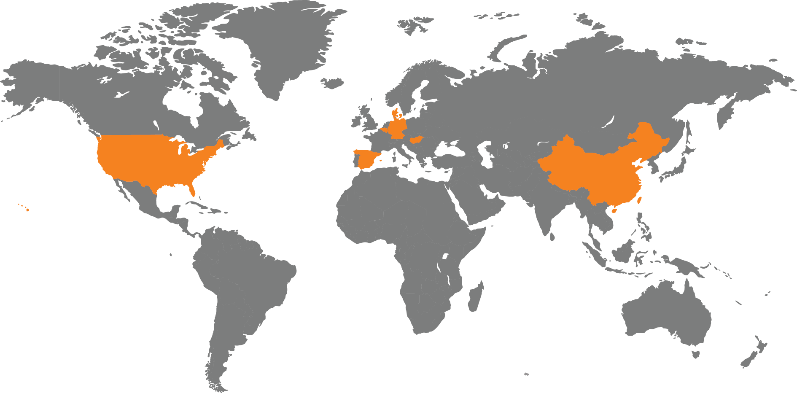

Boyum IT Solutions A/S Headquarters (Denmark)

 | + 45 87 32 90 00 |  |  | facebook.com/boyumit |  |  | Boyum IT Solutions
 | sales@boyum-it.com |  |  | youtube.com/user/boyumit |  |  | Sintrupvej 71b, 1th
 | boyum-solutions.com |  |  | twitter.com/boyumit |  |  | DK - 8220 Brabrand

