Configure HTTPS in BX Service Broker

You have to enable HTTPS, and you have to set a SSL port in BxServiceBroker service configuration

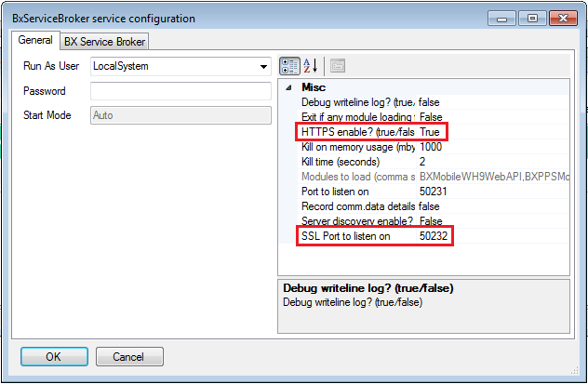

Creating a Client Certificate
First you have to create a certification on your server. You can use MakeCert.exe to create a client certificate.

example:

makecert.exe -r -pe -n "CN=BXServiceBroker" -eku 1.3.6.1.5.5.7.3.1 -sk BX07 -ss my -sr localMachine -sky exchange -sp "Microsoft RSA SChannel Cryptographic Provider" -sy 12 BXServiceBroker.cer
Import
Run mmc.exe
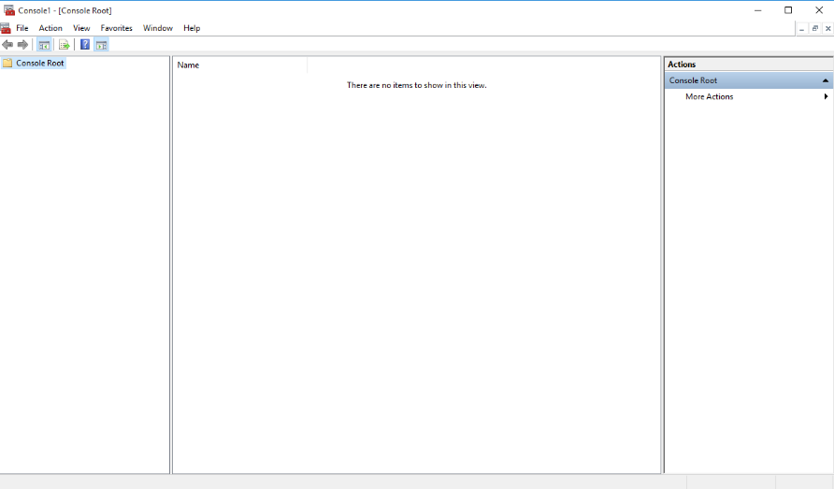
- Go to File-> Add/Remove Snap-In
- Choose the Certificates snap-in.
- Select Computer Account
- Navigate to: Certificates (Local Computer)\Trusted Root Certification Authorities\Certificates
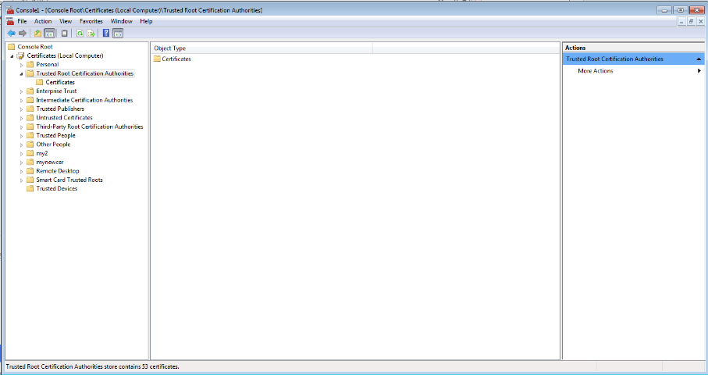

- Right click the Certificates folder and choose All Tasks -> Import.
- Follow the wizard instructions to select the certificate (BXServiceBroker.cer)
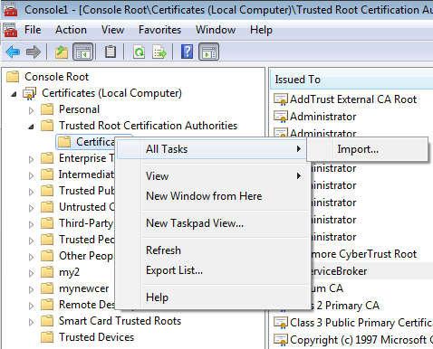
- Open BXServiceBroker certification
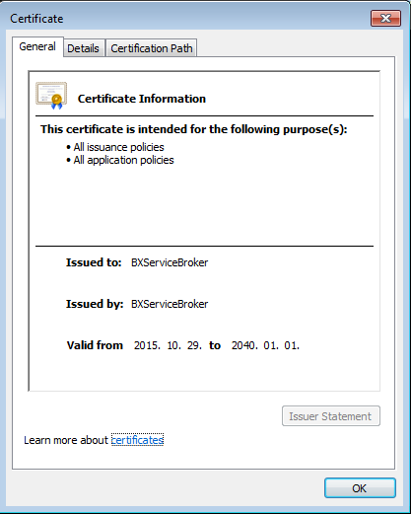

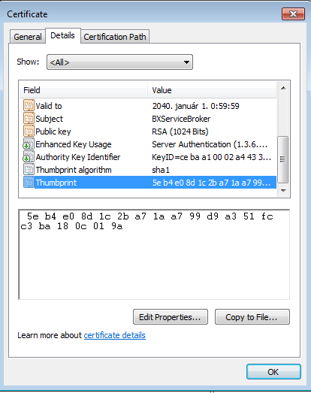
You will need Thumbprint value when you configure the certification to the port number, this number is the certhash.
You can set certification with netsh command:
netsh http add sslcert ipport=0.0.0.0:port certhash=thumbprint appid={app-guid}
where
  - port is the listening port (e.g. 4443); the special IP address 0.0.0.0 matches any IP address for the local machine;
  - thumbprint is the certificate’s SHA-1 hash, represented in hexadecimal;
  - app-guid is any GUID (e.g. {00000000-0000-0000-0000-000000000000}) , used to identity the owning application.

BX Service Broker GUID = {d4deb269-37e6-49db-a9cd-cd74f52d36c3}
example:
netsh http add sslcert ipport=0.0.0.0:50232 certhash=5eb4e08d1c2ba71aa799d9a351fcc3ba180c019a appid={d4deb269-37e6-49db-a9cd-cd74f52d36c3}

