HANA report setting tool

**Overview**

On MSSQL, the connection data is replaced dynamically when printing and there is no need to save the report with the actual connection data.

On SAP HANA, the connection data is not replaced dynamically, and it is necessary to save the selected reports with the actual connection to the right database and schema. With the HANA Report Setting Tool it is possible to modify the connection data for multiple reports.

* Top of Form
* Bottom of Form

**1.Configuration**

* 1. **Run the Produmex.Sbo.Logex.Tools.HanaReportSettingTool.exe.**

When the tool opens, the fields of the Database section are prefilled based on the configuration file of the tool (Produmex.Sbo.Logex.Tools.HanaReportSettingTool.exe.config).

Possible values in the DB Server field:

* Single-Database: *hostname:portnumber*
* Multi-Database: *tdn@hostname:portnumber* where tdn = Tenant Database Name

[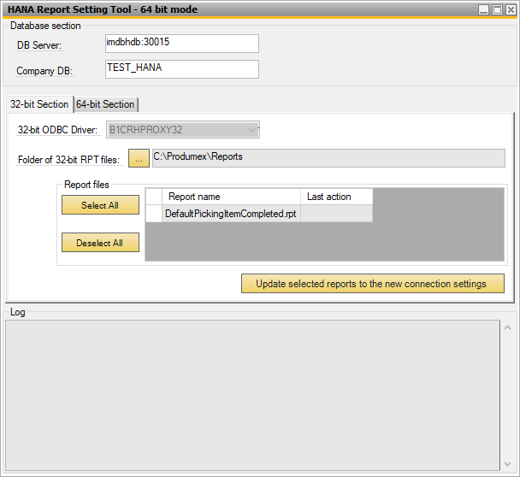](http://wiki.produmex.name/lib/exe/detail.php?id=internal%3Awms%3Ahana_report_setting&media=implementation:wms:tools:hanareport:1.png)

* 1. **Configure the 32-bit section**

32-bit OBCD Driver: On the 32-bit Section tab the default 32-bit OBCD Driver is automatically set.

Folder of 32-bit RPT files: This is the source folder of the reports that you want to modify and this is where the modified reports are saved.

* The default setting for the source folder is *C:\Produmex* or *C:\Produmex\Reports*. If the default folder contains RPT files, they are displayed in the Report Files grid.
* If the source folder does not contain any RPT file, the grid is empty.
* If you want to change the setting, browse another folder.

[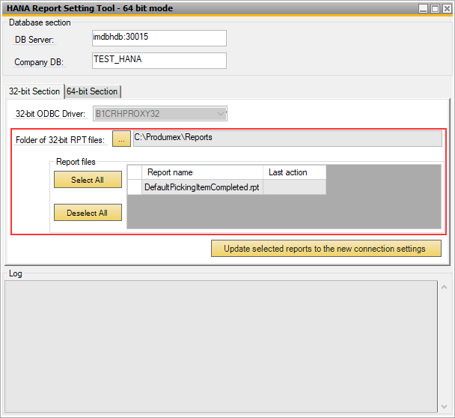](http://wiki.produmex.name/lib/exe/detail.php?id=internal%3Awms%3Ahana_report_setting&media=implementation:wms:tools:hanareport:2.png)

* 1. **Configure the 64-bit section**

64-bit OBCD Driver: On the 64-bit Section tab the default 64-bit OBCD Driver is automatically set.

Folder of 64-bit RPT files: This is the folder where the generated 64-bit reports are saved.

* By default, no folder is set. Create your new folder for the 64-bit reports and browse it for the Folder of 64-bit RPT files field.
* Make sure that you have two different folders for the 32-bit and for the 64-bit RPT files.

[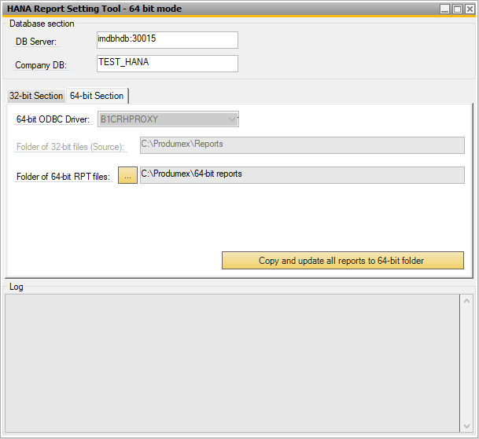](http://wiki.produmex.name/lib/exe/detail.php?id=internal%3Awms%3Ahana_report_setting&media=implementation:wms:tools:hanareport:10.png)

Top of Form

Bottom of Form

**2. Saving reports**

Top of Form

Bottom of Form

**2.1. Save reports with 32-bit**

1. Copy the necessary reports from your installation folder (for example:

*C:\Install\Produmex_WMS_19_1.x64\Reports\HANA*) into your 32-bit RPT file source folder.

All the reports from your source folder are listed in the grid.

2. Select the necessary report files in the grid. Click Select All to select all of the reports in the grid or select the necessary ones one by one.

3. Click Update selected reports to the new connection settings.

4. The tool starts converting the reports into 32-bit versions. In the log window the process is displayed step by step.

The tool creates a new folder named *OLD* within your 32-bit RPT file source folder and saves a copy of the selected report files into the *OLD* folder.

It overwrites the report files by converting them into 32-bit versions. When the process is finished, you can find the 32-bit version files in your source folder.

[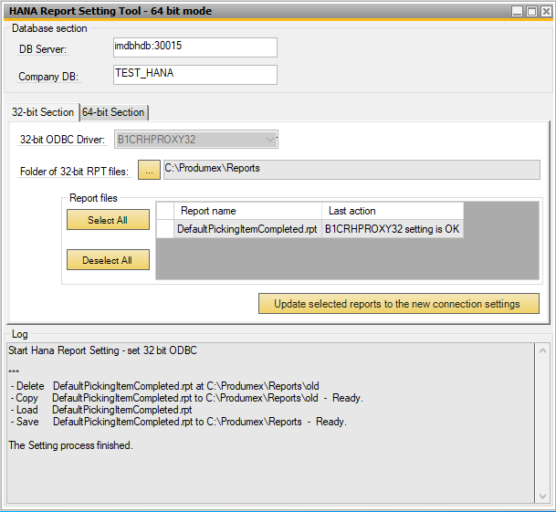](http://wiki.produmex.name/lib/exe/detail.php?id=internal%3Awms%3Ahana_report_setting&media=implementation:wms:tools:hanareport:4.png)

Top of Form

Bottom of Form

**2.2. Save reports with 64-bit**

With this function the tool generates 64-bit RPT files from 32-bit RPT files.

Click Copy and update all reports to 64-bit folder.

The tool starts to generate 64-bit RPT files from all the 32-bit RPT files and saves them to your 64-bit RPT files folder.

[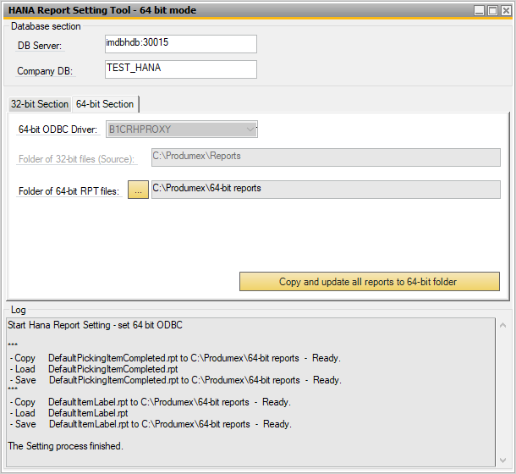](http://wiki.produmex.name/lib/exe/detail.php?id=internal%3Awms%3Ahana_report_setting&media=implementation:wms:tools:hanareport:11.png)

**3. Defining the report path**

Set the appropriate report path in SAP Business One so that the system knows where to find the reports whenever you want to generate a new report in SAP Business One.

1. Open your organization structure and select the Reports tab.

2. Provide the path of your 32-bit RPT files folder or your 64-bit RPT files folder in the Report Path field.

3. Click OK.

[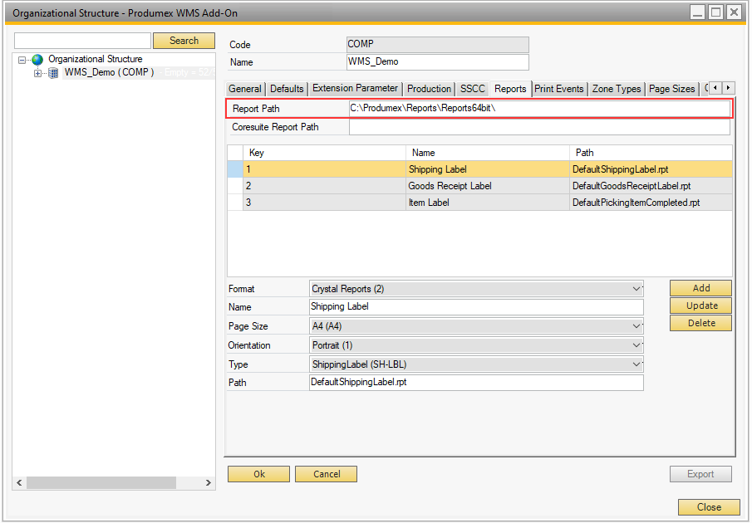](http://wiki.produmex.name/lib/exe/detail.php?id=internal%3Awms%3Ahana_report_setting&media=implementation:wms:tools:hanareport:6.png)