Partial picking of a batch managed item in NON-bin managed warehouse
The issue can be reproduced in any database. The attached database backup contains the following steps:
- Use a batch managed item
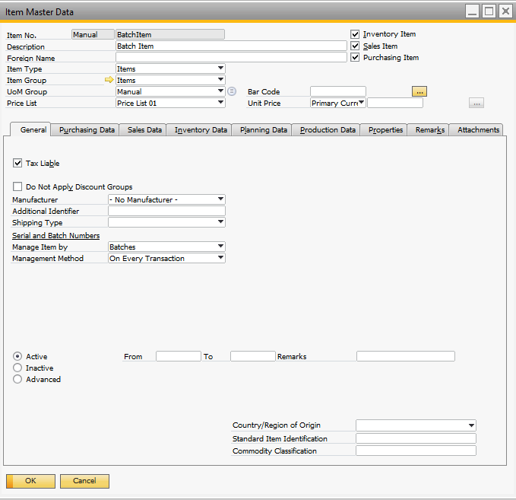
- Receive 30 in three batches to a non-bin managed warehouse:
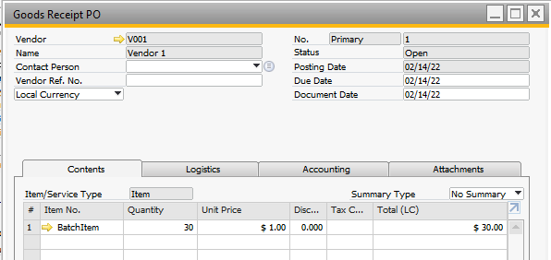
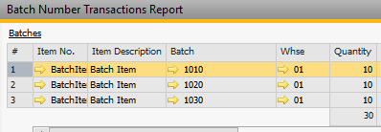
- Create a sales order with 30 and allocate the three batches:
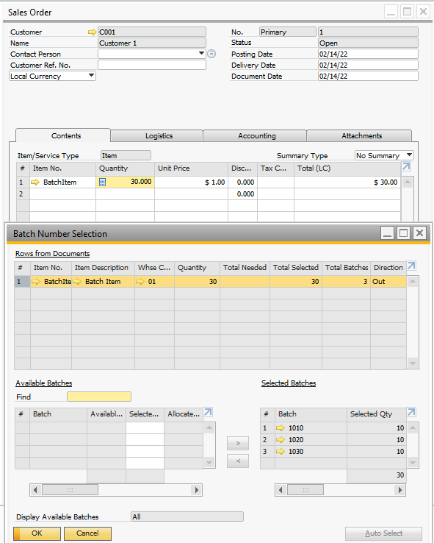
- Generate the pick list
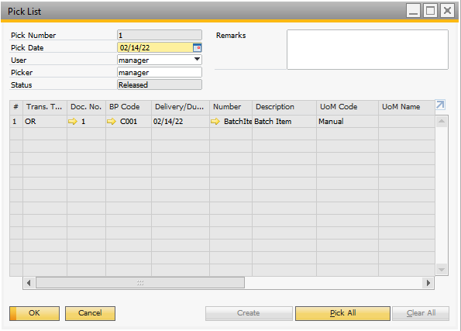
- Use the sample program. If you use different database, modify the pick list docentry and linenum (and the batch if it is different from the example) The program tries to pick the selected batch with the selected quantity (as a
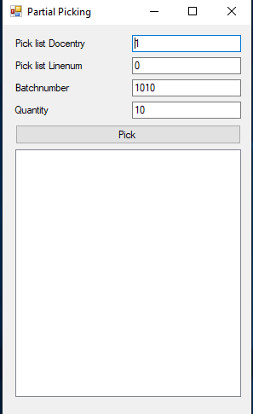
- Click on “Pick”. The program logs the picklist to xml before the modifications and before the update to the folder of the exe file. You will get the error.
